APPLICATION OF BERNOULLI'S PRINCIPLE
Draw on the pictures below an H for high pressure and a L for low pressure. The higher pressure will move the toward the lower pressure, with sometimes disastrous results.
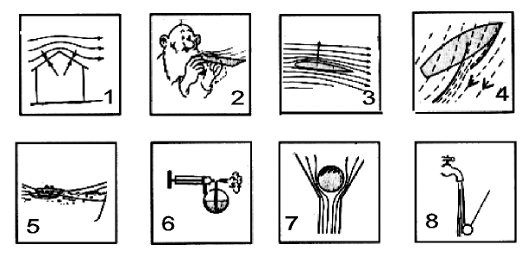
- Air pressure above the roof is less than air pressure beneath the roof.
- The paper rises when air is blown across its top surface.
- Air pressure is less above the wing than below the wing.
- The smaller sail acts as a channel that speeds up the air passing over the main sail.
- Two toys boats are side by side. A stream of water is directed between them. The boats will draw together and collide.
- A vaporizer forces air past the upper end of a tube, reducing the pressure. The greater atmospheric pressure outside the tube forces the liquid up into the tube where it is carried away by the stream of air.
- A hair dryer can keep a ping pong ball trapped in the center.
- Pressure is greater in the stationary fluid (air) than in the moving fluid (water stream). The ball is pushed by the atmosphere into the region of reduced pressure.

