Fast Food Project Help Sheet (Samples and tips)
3 Day Project
Day 1 - Steps 1 & 2 Day 2 – Steps 3 & 4 Day 3 – Steps 5 & 6
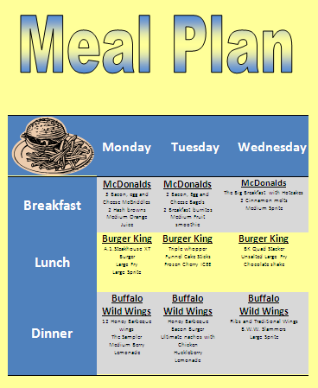
Access directions: schelltech.weebly.com (online textbook)

Step 1 - Meal Plan – Table using Word
- Go to schelltech.weebly.com to access directions
- Create a 3 day meal plan in Word using a table
Hints:
- Each item should never be used more than once, no water
- Make sure to center it on your page and to add publishing features (make it look professional)

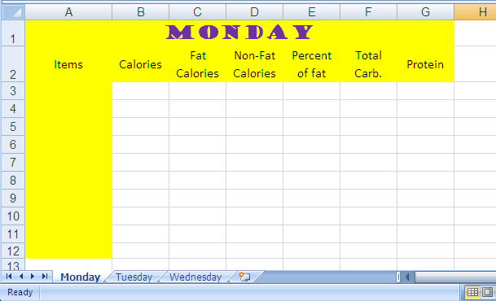
Step 2 – Setting up Spreadsheet
- Read the directions for this step– schelltech.weebly.com
- Open a workbook, label the worksheet tabs as Monday, Tuesday, Wednesday
- Set Monday up just like mine, add your own color
- Leave the rest of the day blank. We will come back to these tabs later.

Step 3 – Adding Formulas
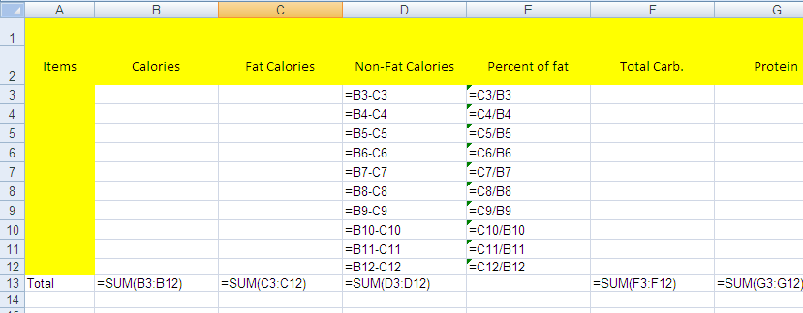
- Read the directions for this step – schelltech.weebly.com
- Adding formulas – click on Monday’s tab
  - Enter your first formula in cell D3
    - drag this formula down for the rest of the column instead of typing it over and over.
  - Enter formula for cell E3
    - drag this formula down as well
  - Enter formula for cell B13
    - drag this formula across to F13

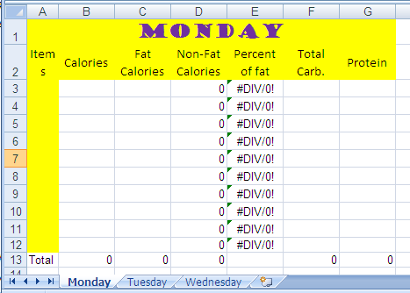

- When this worksheet looks perfect like the one to the right then select all the data on Monday and click copy. Now click on Tuesday’s worksheet tab and click paste in cell A1. You will need to change the title Monday to Tuesday. Now continue this process for Wednesday. Now enter data.

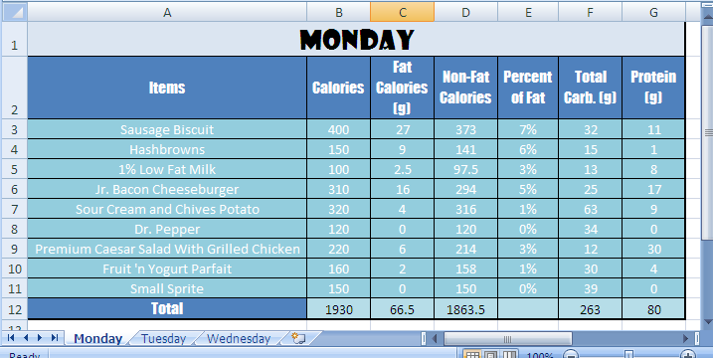

Step 4 – Entering Data
- Read the directions for this step– schelltech.weebly.com
- Enter the data into the workbook.
  - Transfer your food items for each day from the Meal Plan to the Spreadsheet.
  - Now go on the internet to gather the Calories, Fat Calories, Total Carbs, & Protein for each item.
  - Go to each restaurant’s Nutritional Guides

Step 5 – Exercise Sheet
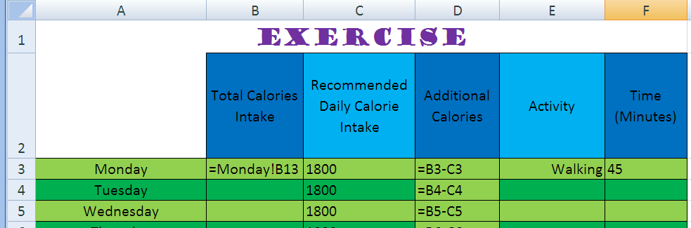
- Read the directions for this step– schelltech.weebly.com
- Creating the EXERCISE tab – you will need to add a new tab to your workbook and make sure you label it Exercise
  - Use the example to the left to help you setup this worksheet.
  - We are going to set the daily calories intake for 1800 (that is an average).
  - In cell B3 you will need to link this formula to your other worksheets.
Click = in the cell, click on Monday’s worksheet tab, click in the cell
with the total calories for Monday and then hit enter. Vola! Do this for each day.
  - In cell D3 enter a formula for Additional Calories. Drag that formula down.
- The last step for this part is to find different activity (using the internet) for each day that will burn your additional calories that you consumed for that day. You will also need to tell me how long you will need to do this activity.

Step 6 - Graphing
Insert 3 graphs anywhere within the workbook. You may only do 1 pie chart out of the 3 graphs.
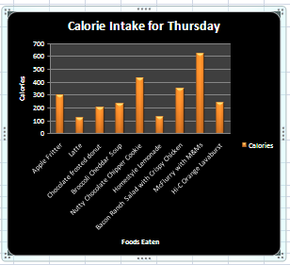
- Highlight/select data that you want to graph
  - Hold down the Ctrl if you are selecting columns that are not next to each other.
- Click on the Insert tab and select desired chart.
  - Make sure all parts of the chart are labeled. You can do this under the chart tools tab, and then click on the label tab
    - Title
    - Legend
    - Vertical axis
    - Horizontal axis

