Story-telling Sculpture April 7, 2010
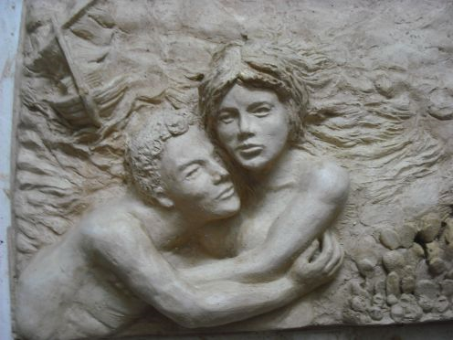
Bas Relief Sculpture
Anonymous
Create a sculpture that is based on a story! You may choose a children’s book, novel, fairy tale, a story-telling song lyric, etc. Use the hand building techniques you learned in class to sculpt your clay. We should be able to tell what story you are referencing from the images you choose.

Before you begin, create at least 3 brainstorming sketches in your sketchbook. These may be 3 different ideas or 3 variations of the same idea.

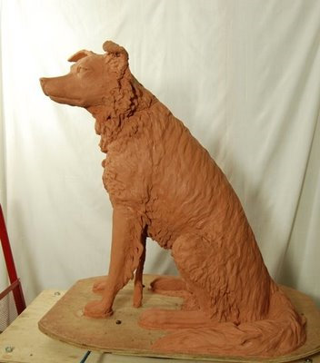
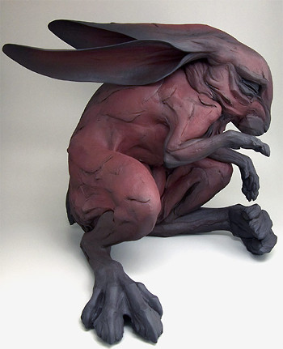
Your sculpture must be at least 10 inches in one dimension (height, width, or depth), have at least two figures/elements (main characters, notable objects, etc…) from your story, and include both additive and subtractive elements.

Grading Requirements:
Beth Sticher
- At least 3 sketches prior to sculpting
- Final sculpture fits size requirements (at least 1 dimension is 10”)
- Used proper hand building techniques
- Includes at least 2 figures/elements from a story
- Inspiration from a story is evident
- Uses both additive and subtractive sculpture techniques
- Shows good craftsmanship and good use of class time

