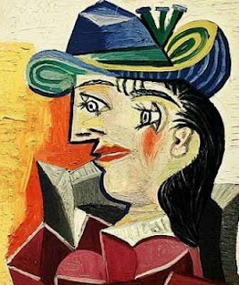 Woman with a Blue Hat
Picasso Faces
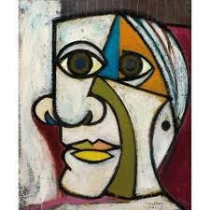“Dora Maar” 1936 by: Pablo Picasso

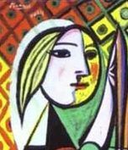 Girl in Front of a Mirror

