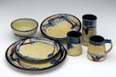 Cup, Plate, and Bowl in the Style of an Artist
Artist Study in Clay
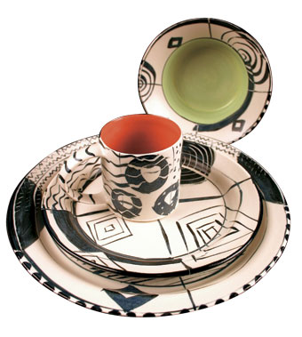Create a cup, bowl, and plate from clay
With sgriffito, glazing or some combination do a surface decoration and treatment in the style of one artist that you choose. You will have to do a write-up for this set, so choose an artist you like that you want to research. You may also pick a style or movement as opposed to specific artist.
