Spirit House
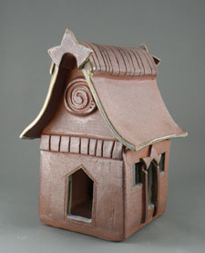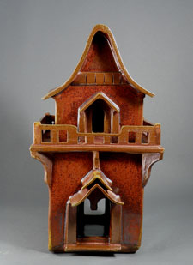
These dwellings are built to bring the divine into your daily life
From Southeast Asia and Thailand we welcome the tradition of the Spirit House (san phra phum) to Whidbey Island. These miniature abodes offer accommodation to the spirits of the land and heavens and bring good luck and prosperity.
Spirit houses can be erected at your office, at home in your garden, by a favorite tree, or by the barn; Anywhere that the spirits need special care and appeasement.
The spirits which reside in spirit houses are known as Phra Bhum Jowthee, or Guardian Spirits of the Land. The two main types of Spirits of the Land are the Guardian of the House and the Guardian of the Gardens.
The main role of the Guardian of the House is to protect and watch over the home, offering financial security and help in business matters. The Guardian of the Garden watches over the garden, special paths and areas of natural beauty. The other seven spirits of the land protect gates and stairwells; animals; storehouses and barns; forests; mountains and fields; temples; waters; and military forts.
Traditionally, when a new home or building is constructed, a spirit house is also constructed for the displaced spirits of the land.
The spirit house was traditionally made of wood. Its construction can be as simple as Thai-style shelter or as elaborate as a Thai palace. Today materials such as brick, concrete, metal, and clay are used. Houses may be adorned with statues, small figures or symbols in the center. Candles and incense are used in daily ritual. Be creative.
By keeping the spirits comfortable and by providing daily offerings - your life will hopefully be more safe and successful.
A few pointers for how to use your spirit house:
- Do not place on the left side of a door
- Do place in front of a tree or a favorite living thing
- It’s lucky if it points north or northeast
- Do not place in the shadow of the house
- Place a few coins under your spirit house to bring financial security and success
- Houses may be adorned with statues, small figures or symbols in the center
- Candles and incense are used in daily ritual
- Before traveling, make an offering
- When making an offering don’t offer leftover food or flowers - everything must be specifically for the spirits
- Be creative and have honorable intentions
- Place objects of special attachment or significance inside your spirit house ( I have a crystal placed inside of mine)
- Include your spirit house in a daily or weekly ritual
