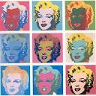
General Art
2 part watercolor painting

Loosely inspired by Andy Warhol’s Pop art paintings
GA will do a two part watercolor painting. The first half will be using realistic colors. The second half will be painted using one color scheme of the students choosing. Schemes are outlined below:
-Primaries – 1st colors (Red, blue, yellow - NO BLACK!)
-Secondaries – 2nd colors made by mixing 2 primaries in equal ratios (Green, violet or orange – NO BLACK!)
-Tertiaries (intermediates) – 3rd colors made by mixing 1 primary with 1 secondary color (Exp.’s blue-green, red-violet, etc. – NO BLACK!)
-Monocromatic – Any one color +black or +white
-Complimentaries – Opposites on the color wheel (Mix 2 complimentaries to make Neutrals!)
-Analogous – Colors close together on the color wheel (Red, red-orange, orange, yellow-orange)

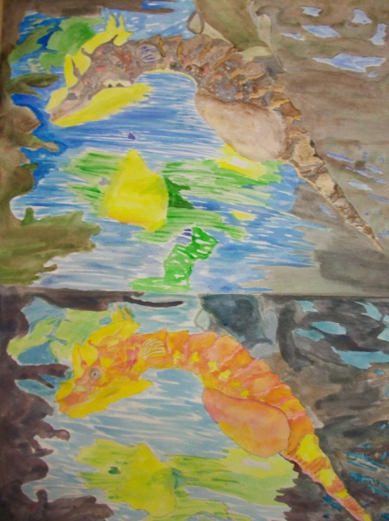

2-P Painting Rubric
Part 1 CS | 10 | 9 | 8 | 7 | 6
Part 2 CS | 10 | 9 | 8 | 7 | 6
Composition | 10 | 9 | 8 | 7 | 6
Transparency | 10 | 9 | 8 | 7 | 6
Craftsmanship | 10 | 9 | 8 | 7 | 6

