In your sketchbook:
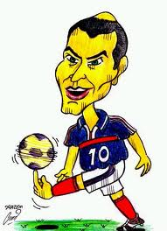
-Create three different cartoon characters faces including lips, nose, eyes, face and include hair.
-Use the reference sheets; make sure to create 3 different faces with various expressions (you can make your own mouths, eyes, etc., these are just sheets to give you ideas – but you may use them as is, too).
(Note: One character must be human or humanoid, but you can create animal or fantasy based characters – please do get creative!!!)
-Add color to these using prismacolor. 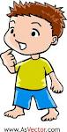
-Choose 1 character to illustrate more fully. Add a body and draw the character on a page in your sketchbook in full; head to toe. CHARACTER MUST BE ORIGINAL!!!
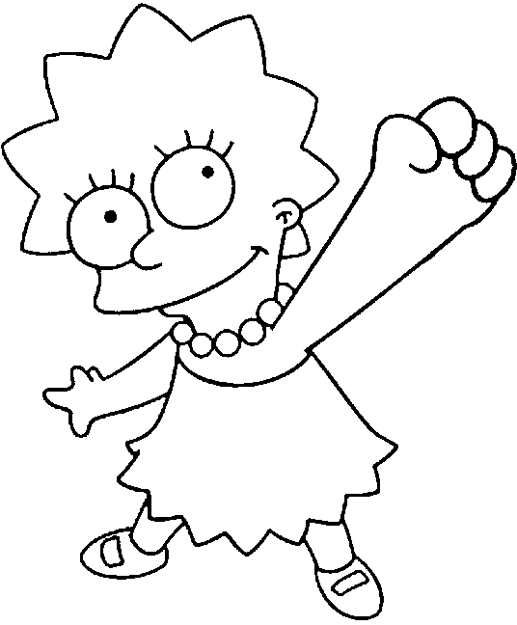
No copying characters like me!!!
-Write a brief overview of your character – include name, age, gender, occupation, hobbies, and some family info. Write this into the sketchbook on the page with the fully illustrated character.
*For your final drawing, do a fully illustrated version or versions of your character in full color, either with prismacolor or markers (sharpies) OR mixed media (both).
*SEPERATELY do a background for your character. These could be hand drawn, cut and colored, collage, etc. We’ll use these to interchange characters and put characters into foreign environments, have characters intermingle, etc. Both the character & the environment should be on copy sized 8 ½ x 11 paper. Your ‘environments’ should be suited to your character. Will these be black and white or color? That is up to you!

