**General Art – Perspective Unit January 28, 2009**

**Read: Art Talk, Chapter 5, Lesson 4, pp. 11-116**

**Vocabulary:**

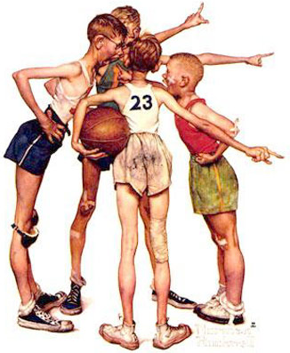

Chiaroscuro

Picture plane

Foreground, middleground, background

Illusion of depth:

Overlapping

Size

Placement

Detail

Color

Converging lines (one point, two point)

**Image by Norman Rockwell**

**On 12”x18” paper, using all six ways listed in your vocabulary list, create an artwork that**

* **makes a statement about something you feel strongly about, or**
* **records an event shared by your friends or family, or**
* **show a place you have visited that has a special meaning for you**

You may use pencil, colored pencil, marker, or any combination.

**Grading criteria:**

50 points total

Perspective

Composition

Creation of form

Creativity

Craftsmanship

Worth 10 points each

