**Transforming Everyday Objects**

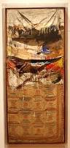 

**IMAGE NINE:** Claes Oldenburg. American, born

Sweden, 1929. *Giant Soft Fan*. 1966–67.Vinyl

filled with foam rubber, wood,metal, and plastic

tubing, fan approx. 10' x 58 7⁄8" x 617⁄8" (305 x

149.5 x 157.1 cm); cord and plug 24' 31⁄4"

(739.6 cm) long.

**IMAGE SEVEN:** Robert Rauschenberg.American, born 1925. *Bed.* 1955.Combine painting: oil and pencil on pillow, quilt, and sheet on wood supports, 6' 3 1⁄4" x 31 1⁄2" x 8" (191.1 x 80 x 20.3 cm).

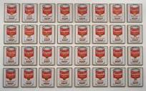

**IMAGE EIGHT:** Andy Warhol. American, 1928–1987. *Campbell’s Soup Cans.* 1962. Synthetic polymer paint on thirty-two canvases,each 20 x 16" (50.8 x 40.6 cm).

**LESSONS**

**17**

**INTRODUCTION**

This lesson looks at two sources of inspiration for artists: everyday objects and **popular culture**.

Artists begin to use everyday objects as inspiration, transforming them into works of

art through the use of different mediums, such as **paint**, sculpture, and printmaking. Robert

Rauschenberg’s *Bed* combines the expressive brushstrokes and the layering of paint that

characterized Abstract Expressionism with **found objects**.

Andy Warhol, Roy Lichtenstein, Claes Oldenburg, and Jasper Johns also drew inspiration

from the everyday, particularly from objects and images from popular culture. Popular

culture comprises the ideas, interactions, needs, desires, and cultural elements of a particular society.

**2. Transform an Object**

Select an everyday object that represents the current time period. Transform this object into their own found artwork using the object and acrylic paints to create a whole new object. Before starting, you should make a sketch showing your plan. There will be automatic sculptural elements based on the object you choose, so choose wisely; then study you r object and make use of it’s sculptural elements in your work. Incorporate the style, lines and form of the object into your own found art piece. BE CREATIVE; you can add other elements besides paint to your object. It can be more literal or more creative, but spend time on the details. Finally, give it a title and identify the Elements and Principles you used to create your unique work of art.

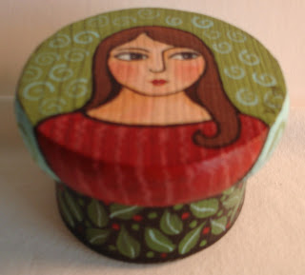 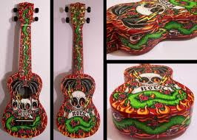

|  |
| --- |
| Use of color 6 7 8 9 10 |
| Craftsmanship 6 7 8 9 10 |
| Design plan 6 7 8 9 10 |
| Composition 6 7 8 9 10 |
| Creativity 6 7 8 9 10 |

