Elements and Principles of Design Book

For our first project, design a small accordion fold book illustrating the Elements and Principles of Design.
First fold 2 papers in half (hamburger) & then in half again.
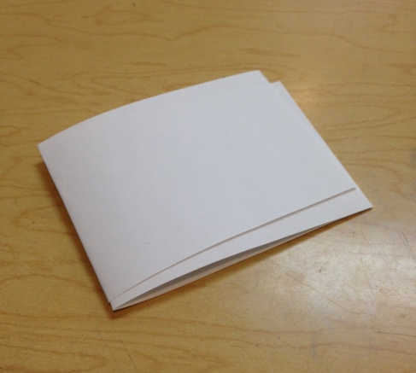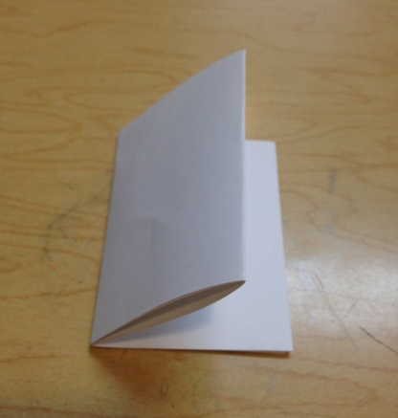
Pull apart and overlap the 2 middle pages to make 7 pages (1 for each Element & 1 for each Principle)
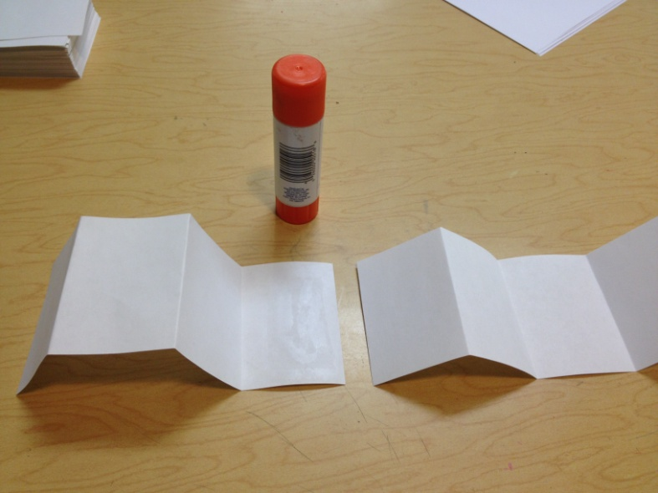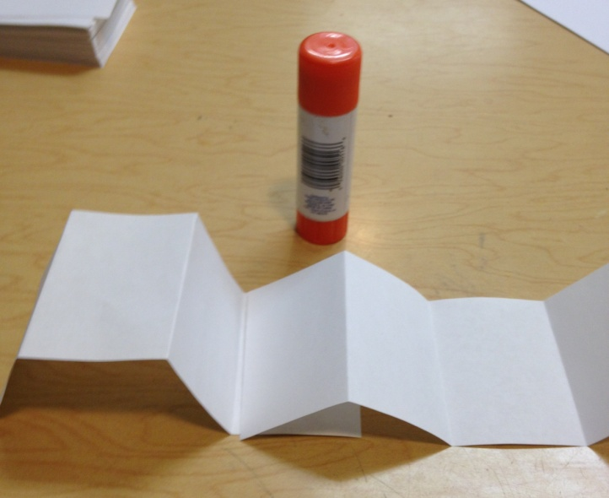
Glue one side of the middle page like shown above Overlap the second page like shown above & glue *Tip: Make sure the 2 pages you overlap & glue line up perfectly or folding will be tricky – be picky!

Refold any folds that go the wrong way so all folds go back and forth accordion style (looks zigzag at the top)
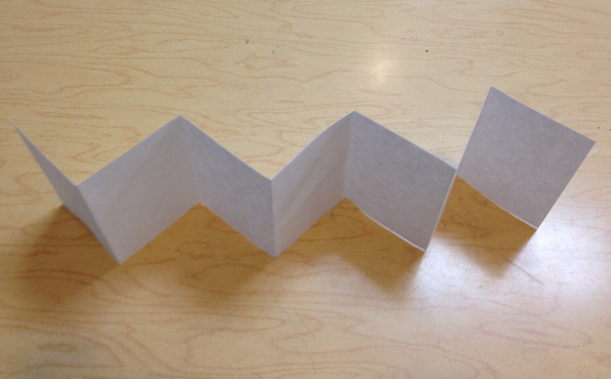
Now add your ‘definitions’ – illustrate the concepts
-Elements go on the first side
-Principles on the second side
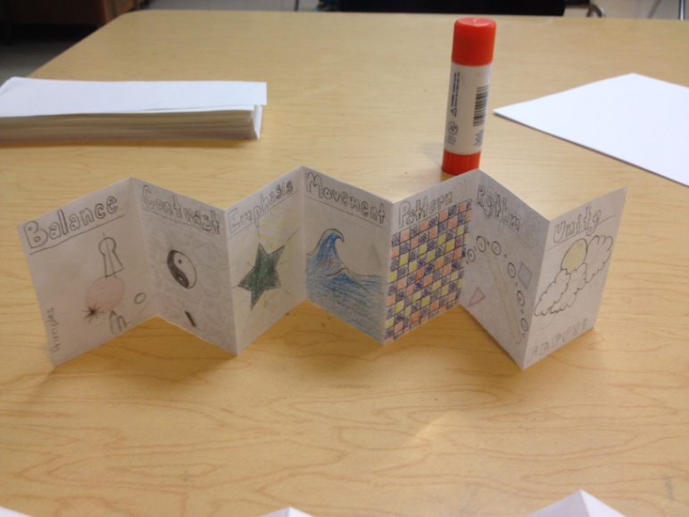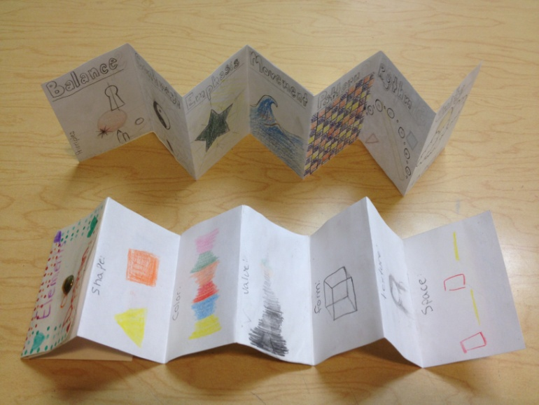
Attach your cover with a brad (only goes through ONE page of the book/illustrations & ONE side of the cover – or it won’t work/unfold)!

