[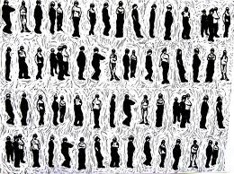](http://www.google.com/imgres?q=prints&hl=en&safe=active&sa=X&rls=com.microsoft:en-us:IE-SearchBox&biw=1024&bih=607&tbm=isch&prmd=imvnsr&tbnid=Wn_jQdXDy1qmpM:&imgrefurl=http://www.joyceellenweinstein.com/prints&docid=GJQwBZrTT9X8lM&imgurl=http://www.joyceellenweinstein.com/uploads/images/Prints/J-Dubs-Prints-011.JPG&w=2480&h=1844&ei=YgigTpXnMeePsQKr3KCeBQ&zoom=1)

[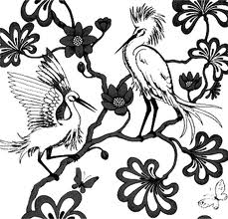](http://www.google.com/imgres?q=prints&hl=en&safe=active&sa=X&rls=com.microsoft:en-us:IE-SearchBox&biw=1024&bih=607&tbm=isch&prmd=imvnsr&tbnid=9nqgY5muZ9ipbM:&imgrefurl=http://www.designboom.com/history/broadhurst.html&docid=vaO77aBLio8tiM&imgurl=http://www.designboom.com/history/broadhurst/03.gif&w=330&h=316&ei=YgigTpXnMeePsQKr3KCeBQ&zoom=1) [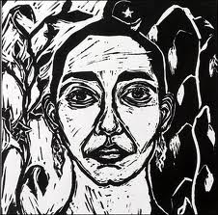](http://www.google.com/imgres?q=printmaking&hl=en&safe=active&sa=G&rls=com.microsoft:en-us:IE-SearchBox&biw=1024&bih=607&tbm=isch&tbnid=UXspUl2xOR0dhM:&imgrefurl=http://blogs.solano.edu/arts/%3Fp%3D140&docid=3GBalbK3p-2SrM&imgurl=http://blogs.solano.edu/arts/wp-content/uploads/2011/02/Hashim_Reem-Printmaking.jpg&w=427&h=420&ei=xgigTvmLC-WKsAKDhOWYBQ&zoom=1)

[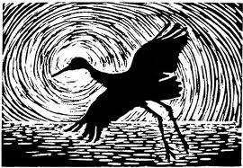](http://www.google.com/imgres?q=printmaking&hl=en&safe=active&sa=G&rls=com.microsoft:en-us:IE-SearchBox&biw=1024&bih=607&tbm=isch&tbnid=FDI6GixwSZVKzM:&imgrefurl=http://www.arlingtonchristian.org/printmaking.html&docid=BGXAsjaWi7B48M&imgurl=http://www.arlingtonchristian.org/images/printmaking.jpg&w=430&h=298&ei=xgigTvmLC-WKsAKDhOWYBQ&zoom=1) [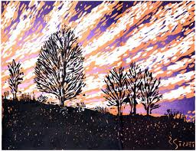](http://www.google.com/imgres?q=printmaking&hl=en&safe=active&sa=G&rls=com.microsoft:en-us:IE-SearchBox&biw=1024&bih=607&tbm=isch&tbnid=ZApTEIabxsF2QM:&imgrefurl=http://www.free-vectorart.com/printmaking-art/&docid=rChk69rm4IrzrM&imgurl=http://www.free-vectorart.com/wp-content/uploads/2011/02/printmaking-art.jpg&w=432&h=333&ei=xgigTvmLC-WKsAKDhOWYBQ&zoom=1)