<http://www.youtube.com/watch?v=S9oG7fzG7HA>

[](http://1.bp.blogspot.com/-tzpP2wiLlgk/Tij5tCSsigI/AAAAAAAAHLk/92zQF-oAdoQ/s1600/Alexander+Calder+Mobile+%286%29.gif) [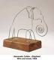](http://img.artknowledgenews.com/files2009a/Calder_Elelphant.jpg)

Alexander Calder

American artist

Modern sculptor

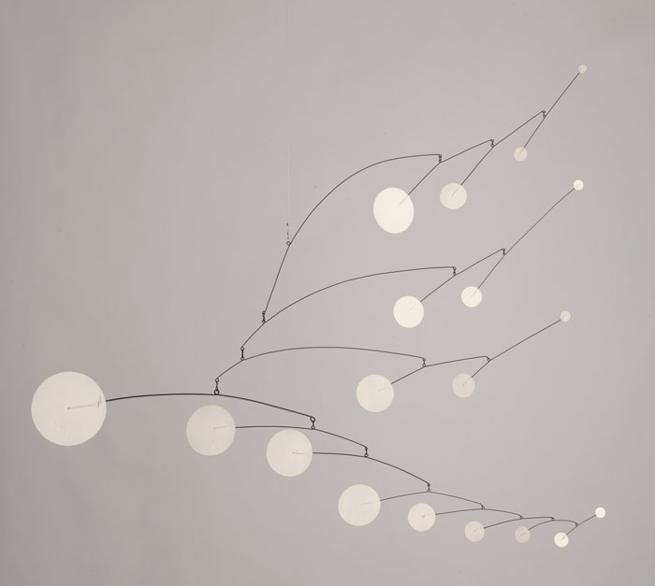 [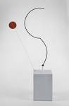](http://www.google.com/imgres?imgurl=http://arttattler.com/Images/NorthAmerica/NewYork/Whitney/Alexander%20Calder/calder_halfcircle.jpg&imgrefurl=http://arttattler.com/archivecalder.html&usg=__c5MphMkh6MAb56BaKVh92GHyKcg=&h=1031&w=673&sz=39&hl=en&start=13&zoom=1&tbnid=KHBgc5goQD2RFM:&tbnh=150&tbnw=98&ei=9VduTrbrN8yFsgLX-sCkBA&prev=/search?q=alexander+calder&hl=en&safe=active&sa=X&rls=com.microsoft:en-US&tbm=isch&prmd=ivnsol&itbs=1)

[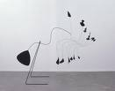](http://www.google.com/imgres?imgurl=http://3.bp.blogspot.com/-90Xn3hhcW4M/Tiji-JAo12I/AAAAAAAADak/rPTWAMZq9RU/s1600/Alexander+Calder%2527s+113th+birthday+%25282%2529.jpg&imgrefurl=http://black-4.blogspot.com/2011/07/alexander-calder-113th-birthday.html&usg=__mZ9Dtho99ZtFup9R--0Rf_bCrcY=&h=408&w=520&sz=15&hl=en&start=18&zoom=1&tbnid=VFZyuoEx9ahTdM:&tbnh=103&tbnw=131&ei=9VduTrbrN8yFsgLX-sCkBA&prev=/search?q=alexander+calder&hl=en&safe=active&sa=X&rls=com.microsoft:en-US&tbm=isch&prmd=ivnsol&itbs=1) [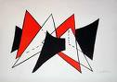](http://www.google.com/imgres?imgurl=http://www.djtfa.com/images/artwork/full/art00250.jpg&imgrefurl=http://www.djtfa.com/cgi-bin/art/gallery.cgi?category=Calder&type=gallery&usg=__Qo63uyOYmLggtj4kIKEXlPwrNgQ=&h=300&w=425&sz=12&hl=en&start=16&zoom=1&tbnid=pLFJZ5Byr6nTDM:&tbnh=89&tbnw=126&ei=9VduTrbrN8yFsgLX-sCkBA&prev=/search?q=alexander+calder&hl=en&safe=active&sa=X&rls=com.microsoft:en-US&tbm=isch&prmd=ivnsol&itbs=1) [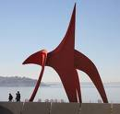](http://www.google.com/imgres?imgurl=http://therepublicofless.files.wordpress.com/2010/07/eagle-alexander-calder.jpg&imgrefurl=http://therepublicofless.wordpress.com/2010/07/28/alexander-calder-circus-master/&usg=__hJsGEBIt-gKfvzs5s8CHQ03V248=&h=475&w=500&sz=156&hl=en&start=14&zoom=1&tbnid=cvPzTfIosxXBgM:&tbnh=124&tbnw=130&ei=9VduTrbrN8yFsgLX-sCkBA&prev=/search?q=alexander+calder&hl=en&safe=active&sa=X&rls=com.microsoft:en-US&tbm=isch&prmd=ivnsol&itbs=1)

[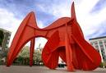](http://www.google.com/imgres?imgurl=http://s3.amazonaws.com/trazzler-images/af/28090/calder.sculpture.grand.rapids.jpg?1241783202&imgrefurl=http://www.trazzler.com/trips/calder-plaza-building-in-grand-rapids-mi&usg=__EOZvuHzMEZLI_-J0snWZcDVjE2I=&h=332&w=483&sz=49&hl=en&start=4&zoom=1&tbnid=q0LzN5ppZzWkKM:&tbnh=89&tbnw=129&ei=P1luTpvCF82GsgKYysiXDA&prev=/search?q=grand+rapids+calder&hl=en&safe=active&sa=X&rls=com.microsoft:en-US&tbm=isch&prmd=ivnsol&itbs=1)