Applied Design Overview MP1
Dolls 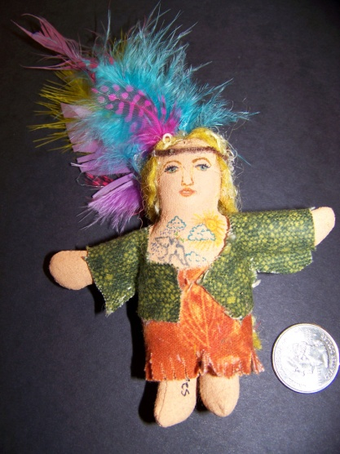
Jewelry Design 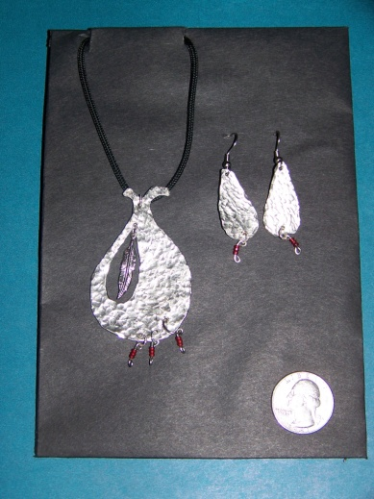 (Sketchbook & Finished piece)
Book Jacket Design 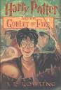 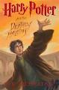 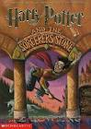
Invention OR Toy 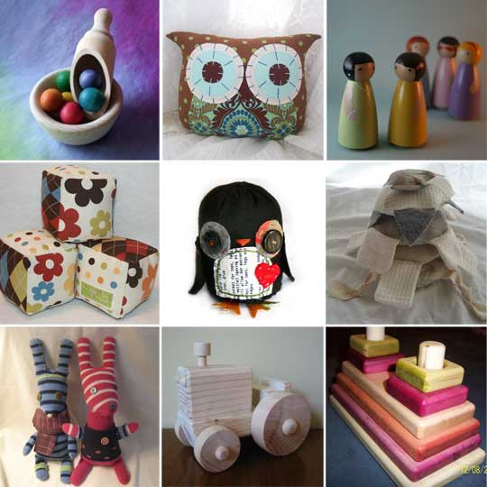
(With prototype)

