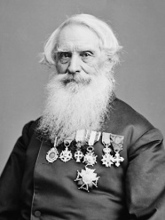 Samuel F.B. Morse, in full Samuel Finley Breese Morse (born April 27, 1791, Charlestown, Mass., U.S.—died April 2, 1872, New York, N.Y.), American painter and inventor who, independent of similar efforts in Europe, developed an electric telegraph (1832–35). In 1838 he developed the Morse Code.
Artist Inventors
http://www.britannica.com/EBchecked/topic/393059/Samuel-FB-Morse
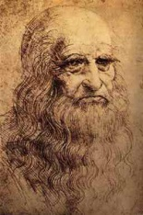 Leonardo DaVinci the renaissance man and one of the most famous artists in the world was also an incredible inventor. This gallery is full of drawings made by Leonardo DaVinci of his ideas for inventions.
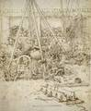Artillery Park | 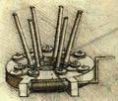Stretching Device for a Barrel Spring 1498 | 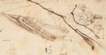Designs for a Boat (1485 - 1487) | 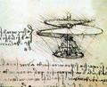Ornithopter Flying Machine
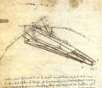Design for a Flying Machine 1488 | 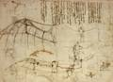Design for a Flying Machine 2 | 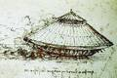Armoured Car | 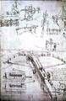Giant Crossbow

FUNCTIONAL ART
Your next assignment is to create a functional toy OR an invention. You will design your toy or invention from start to finish. You must determine the materials you’ll need to use.
Hints: For toys, ‘functional’ could mean educational, or it has a hidden use (secret storage compartment), it rolls or has jointed arms, etc.
For inventions, your invention should solve a problem or greatly improve upon an already invented invention.
In your sketchbook, give me 3 detailed drawings of your toy or invention – front view, top down view, & a side view. Make notes about materials & be detailed in your work. Drawings should be scaled. Must be in full color (use markers or colored pencils).

