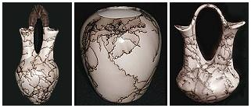
COIL POTS
With a brief Native American History
Wedding vases and other horsehair pottery from a Navajo-owned crafts store.
The clay body is a necessary component of pottery. Clay must be mined and purified in an often laborious process, and certain tribes have ceremonial protocols to gathering clay. Different tribes have different processes for processing clay, which can include drying in the sun, soaking in water for days, and repeatedly running through a screen or sieve.
Acoma and other Pueblo pottery traditionally pound dry clay into a powder and then remove impurities by hand, then running the dry powder through a screen, mixing it with a dry temper, and then mixing water to create a plastic paste.^{[2]} In preparing the clay, potters spend hours wedging it to remove air pockets and humidity that could easily cause it to explode during firing. The clay then needs to "cure" over time.^{[3]}
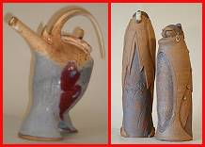
Contemporary ceramic figurines and pots by a Navajo artist.
Coiling is the most common means of shaping ceramics in the Americas. In coiling, the clay is rolled into a long, thin strands that are coiled upon each other to build up the shape of the pottery. While the potter builds the coils up, she also blends them together until there was no trace of the ropes of clay entwined to form the pot, no deviation in the thickness of the walls, and therefore no weaknesses.
Potter's wheels were not used prior to European contact and are only used today by a limited number of Native American artists. Pinch pots and other small clay objects could be formed directly by hand. Hohokam potters and their descendents in the American Southwest employed the paddle-and-anvil technique, in which the interior clay wall of a pot was supported by an anvil, while the exterior was beaten with a paddle, smoothing the surface.^{[4]} http://en.wikipedia.org/wiki/Ceramics_of_indigenous_peoples_of_the_Americas

