Start with a list….

List the 5 things most important to you
1. Husband (family)
My
Lists->
2. Other family
3. Friends
4. Beliefs/religion
5. Home

List your 5 biggest pet peeves
1. Intolerance
2. Ego/Egomaniacs
3. Haughtiness (stuck up)
4. Extreme criticism
5. Extreme greed

WHY? Because the BEST ART is PERSONAL; it cannot be separated from the artist & vice versa…
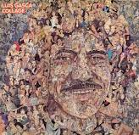

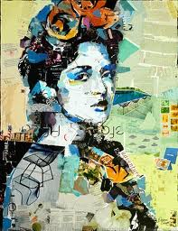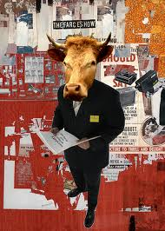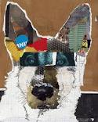
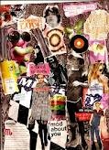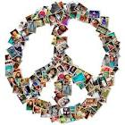
~ Tell your story with pictures (& limited or no text)
~ 50% drawn by hand!
~ 12 x 18
~ Come up with a focus & a good title!

