'Rattles are one of the oldest instruments known to mankind. Whether created from gourds, bones, hides or CLAY, all were used for centering and ceremony. 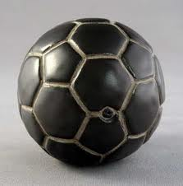 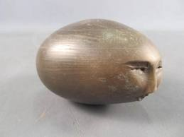
Ceremonies were for birth or dying. They were used to insure the success of the hunt or the harvest of the maize, for healing or for love, to seek inner vision or to ensure the fertility of the clan.
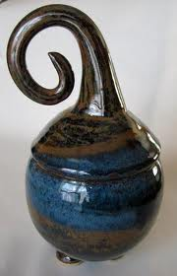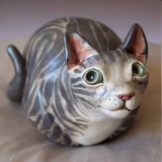
The addition of grains to the rattles insured their power. Magic stones, personal totems, feathers or other sacred objects were added to rattles for greater power.
The rattles here were created to bring peace and inner awareness of your personal truth. Use your rattle to open the heart and find your center. Use your rattle in peace and love and bring your vision to life.'

