Proportions of a Head
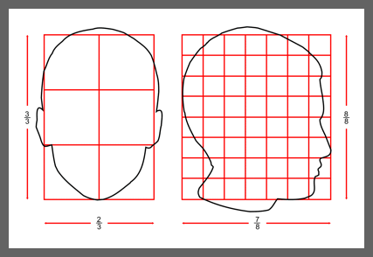
Although the proportions of a head will vary from person to person and change slightly with age, there are some basic principles you can follow to improve your drawing. You can use these to check the general size, shape and position of features in your drawings.
If you view a head from the front, its width is approximately two thirds of its height.
If you view a head from the side, its width is approximately seven eighths of its height.
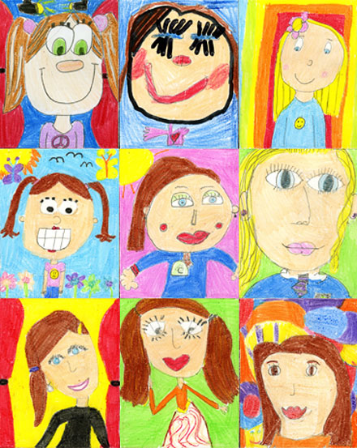

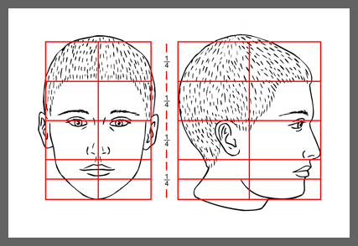
The proportions of the head can be divided horizontally into four equal quarters.
1. The first quarter measures from the top of the head down to the hairline.
2. The second quarter measures from the hairline down to the eyes in the middle of the head.
3. The third quarter contains most of the features. At the top of this section the eyes are usually level with the ears, and at the bottom the nose is roughly level with the ear lobes.
4. The final quarter stretches from the base of the nose to the chin with the mouth positioned just above the halfway mark.
These proportions will only work if we share the same eye level as the subject. They will become distorted if we view the head from above or below.

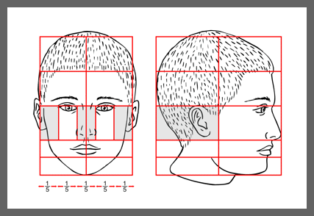
Many artists start a portrait with the eyes as they are the focal point of any face. The following proportions should help you with their scale and position in relation to the other features.
The eyes are situated approximately half way down the head.
If you view a head from the front, the distance across the eye is similar to the distance between the eyes.
The distance between the eyes is similar to the breadth of the nose.
As you can see from the illustration above, these distances work out at approximately one fifth of the width of the face.
Note the position of the ear in the profile view. It sits to the left hand side of the vertical line which bisects the head.

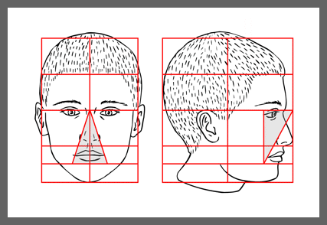
If you view a head from the front, a triangle drawn from the centre of the head through either side of the nose will establish a good proportion for the breadth of the mouth.
If you view it from the side, note how the eyes, nose and mouth fit into a rectangle whose diagonal creates a good line to position the corners of the nose and mouth.

No more eyes too high in the head!

