Title (1pt)

List the three Intermolecular Forces and describe them (1 pt):
1.

2.

3.

Hypothesis (2 pts):
Write a hypothesis describing which liquid would evaporate faster, water, rubbing alcohol, or acetone. Describe why you ranked them that way.

Materials (1 pts):
Write the materials used in this lab.

Procedure (2 pts):
Each member of the class will be responsible for testing the evaporation rate for three substances acetone, isopropyl alcohol, and water. The evaporation rate for a substance is the time it takes a substance to change its physical state from a liquid to a gas. Measure a distance on your lab station that is 10cm long and mark that distance in pencil. Bring a beaker of one of the substances to your lab area. Dip your index (pointer) finger into the liquid up to your first knuckle. Smear the substance from the beginning to the end of your 10 cm line and start the stop watch. Time how long it takes for the material to completely evaporate. Record the time. Repeat this process for the other two materials. Record the time for evaporation for each material on the dry erase board.

Data (4 pts):
Draw each of the three molecules that we are testing and identify the difference in electonegativity for every bond in each molecule. Rank each molecule from most polar to least polar.

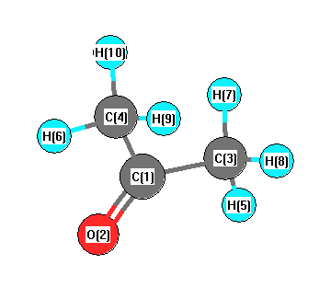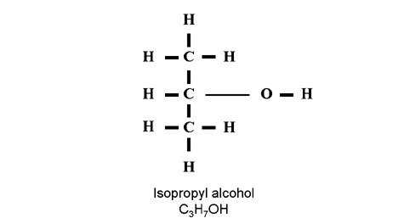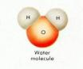
Acetone

Calculations (1 pt):
Calculate the average evaporation time for each liquid (show your work!)

Conclusion
Write one paragraph describing purpose of the lab, the hypothesis being tested, and how you went about testing that hypothesis. (1 pt)
Write another paragraph describing the results of your lab (actually use the numbers that you calculated), how the results compared to the difference in electronegativity for the bonds of each liquid and the polarity of each substance. (2 pt)
Finally, write a paragraph in which you describe what you have learned about the relationship between evaporation rate (vapor pressure) and intermolecular forces. State if your hypothesis is correct or not and explain why. (2 pts)
Draw a the molecule for methane/natural gas (CH₄) and propane (C₃H₈) and identify if the bonds are polar and if the molecules are polar. Both of those are gases that are burned to heat homes. Based on the pictures that you drew of those molecules and the polarities of those molecules, identify what intermolecular force affects those molecules and if it is surprising that those molecules are a gas rather than a liquid or solid. (2 pts)

