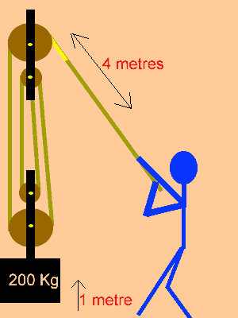
What is the resistance force of gravity on the mass?

What is the work out? What is the work in?

What is the effort force? What is the efficiency of this pulley system?

What is the mechanical advantage of this system? What is the ideal mechanical advantage?

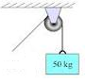
What is the resistance force of gravity on the mass?

What is the work out? What is the work in?

What is the effort force? What is the efficiency of this pulley system?

What is the mechanical advantage of this system? What is the ideal mechanical advantage?

