Help Sheet - Creating a Weebly Site

Major Event Planning Project

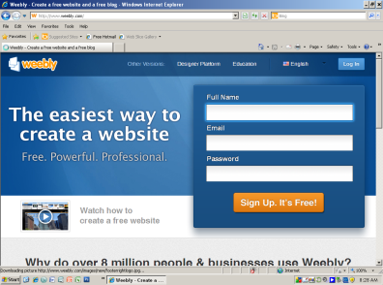

1. Type in the URL weebly.com
2. Enter in the sign up box your Full Name, Email address *(this is what you are going to use to*

*log in every time you work on your Weebly),* and a password. Click sign up. It’s Free!

*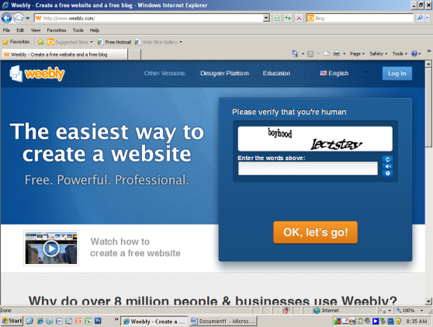* (For your information Weebly will only let you create to site for free!)*

1. Next step is to verify that you’re human. Type both words and then click, Ok, let’s go!

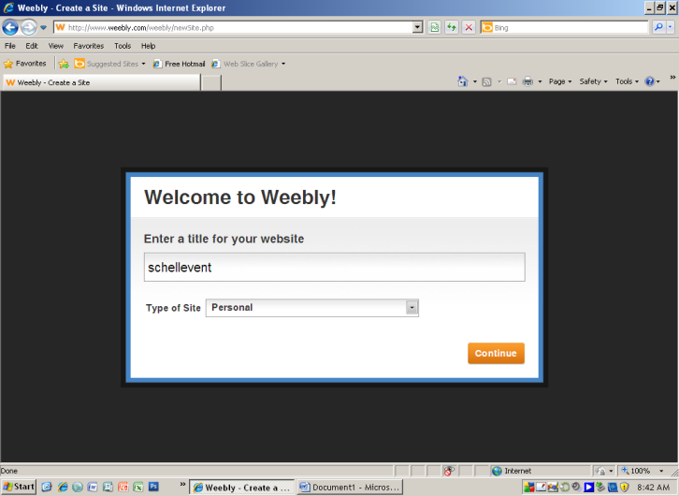

1. Enter a title for your website: **your last name event**
2. Type of site: **personal**

6. Use a Subdomain of Weebly.com: *(this is the only free choice)*

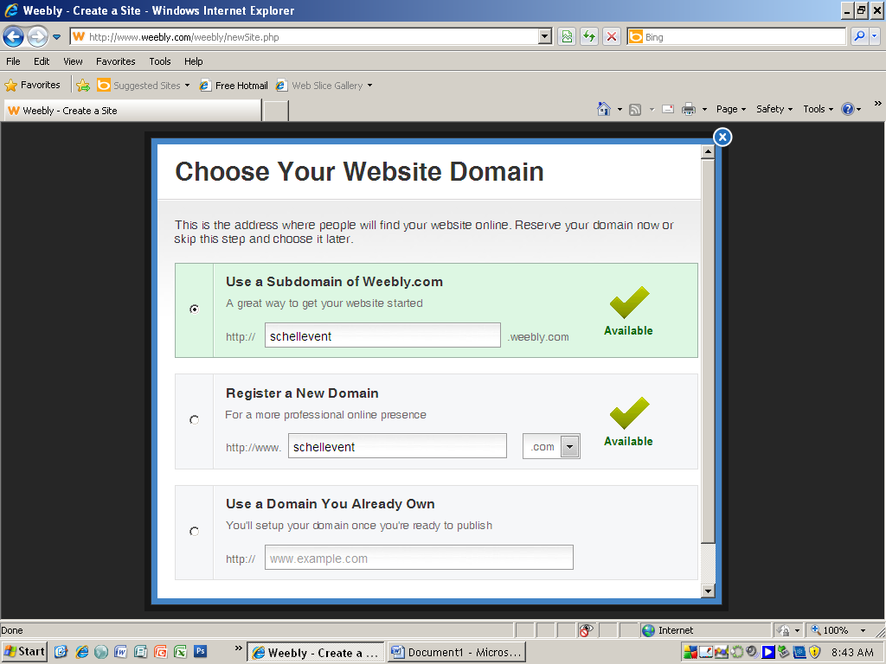**your last name event**

Then click continue

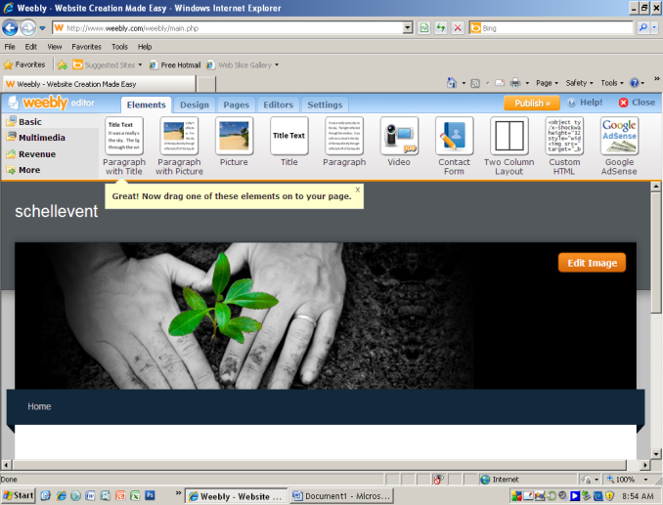

1. IT’S TIME! - Create your Weebly site.
   1. **DESIGN** tab - pick a page design for your site (background)
   2. **PAGES** tab -create each page**.** Make sure you hit save when you are done with these pages:
      * 1. **Home Page**
        2. **Additional Page:** Ex.– Honeymoon, After Party, Special Equipment **(**what was your second page of your spreadsheet)
        3. **Links Page:**
   3. **ELEMENTS** - design each page by choosing a feature such as *title, picture, columns, paragraphs, . . .*
      1. Click on the icon for the feature you want to use and then drag it down on the page and drop it.

|  |  |  |
| --- | --- | --- |
| ***Webpage Criteria/ Rubric (5 points for each bullet)*** | | |
| ***Home Page:***  - Title  - Graphic/Picture (additional from background)  - Information: who, what, where, when . .  - Contact information  ***20 points*** | ***Additional Page:***  ***-*** Description of page or what will happen  - Include a bulleted list of items (these could  be to go or what you will be doing)  - Graphic/Picture  ***15 points*** | ***Links Page:***  ***-*** Link your  ***- Invitation (desktop publishing)***  ***- Guest List (database)***  ***- Budget (spreadsheet)***    ***15 points*** |

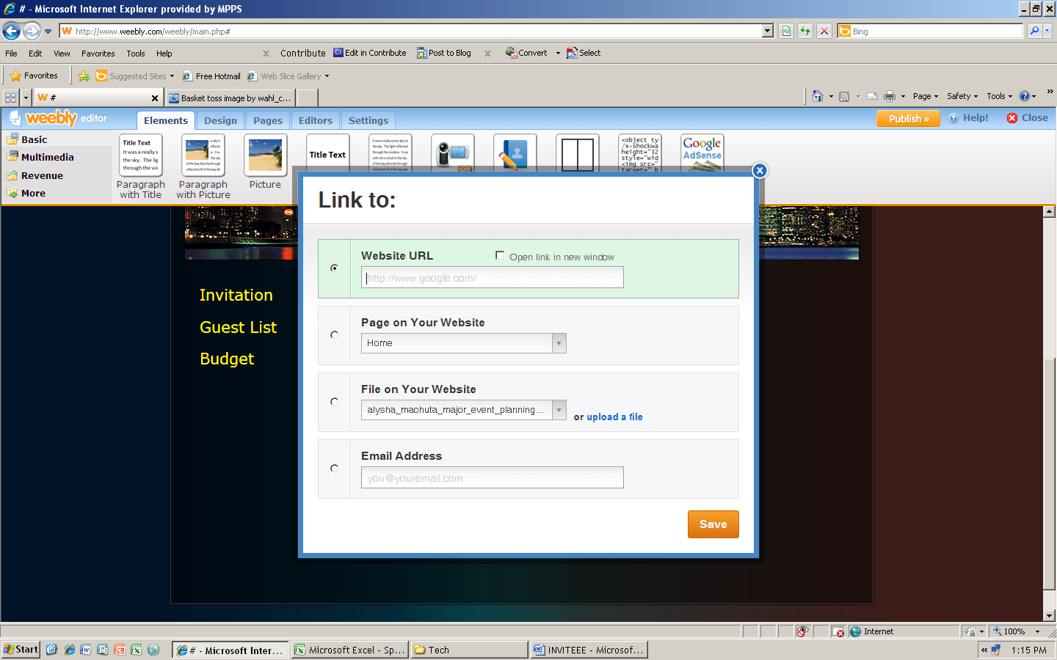

***Adding a Link:***

1. *Drag and drop title icon onto page. 4. Click on upload file*
2. *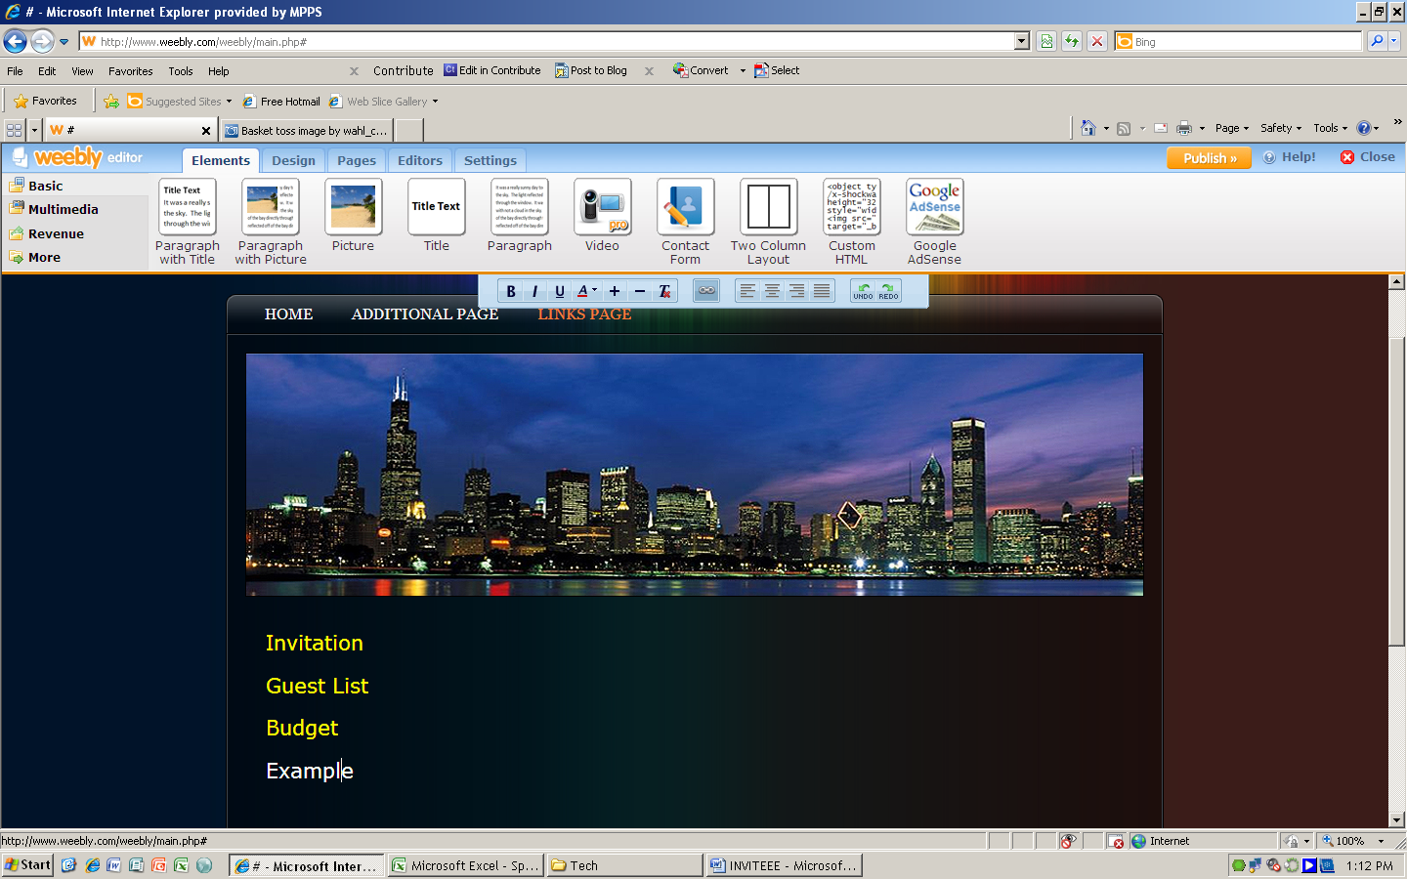Type link name, highlight name 5. Browse & find file*
3. *Click on chain link icon*