[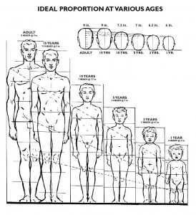](http://www.idrawdigital.com/wp-content/uploads/2009/01/prop2.jpg)

[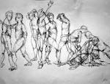](http://www.google.com/imgres?imgurl=http://th03.deviantart.net/fs10/PRE/i/2006/132/9/d/Gesture_Drawings__Yoga_Steve_by_WingedIllusion.jpg&imgrefurl=http://wingedillusion.deviantart.com/art/Gesture-Drawings-Yoga-Steve-33209533&usg=___V97oXq9Kh_ADsK0D37Yag_AXUY=&h=778&w=1026&sz=234&hl=en&start=10&zoom=1&tbnid=O3ZbCeCERnDHiM:&tbnh=114&tbnw=150&ei=KGQMT4r1IYqzsALI-oyEBg&prev=/search?q=gestural+drawing&hl=en&safe=active&sa=X&tbm=isch&prmd=ivns&itbs=1)

