Getting Started: tools
- Pencils: It's always good to have a handy supply of pencils with different leads. Have a good pencils for drawing (most artists usually use 2H up to 4B range).
- Paper: For any drawing, using good paper is essential. In this case, we're going to be doing a lot of layers, adding pencil, and erasing, so you'll want a paper that can take a bit of a beating. My favorite is to use 80lb drawing paper.
- Erasers: I usually use a big white vinyl eraser for big mistakes, but whichever you prefer is fine. One thing that I will highly recommend is to get a 'Tuff Stuff eraser stick'.
- Blending Utensils: Sure, you can be old fashioned and use your fingers, but realize the oil from your hands can damage your drawing. I prefer to use my stump (aka stomp).
- Dusters: Optional, but nice to have if you have the habit of smearing your drawing with your hands. If you don't have one, remember to blow or shake your drawing to get the crud off... never wipe it away with your hands! (I've had many smearing disasters. Not fun.)

Down and Dirty: drawing hair
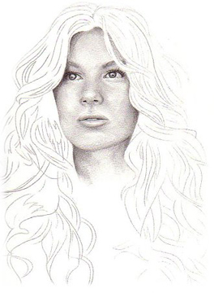

Layout: putting down the basics
Here I've started with a face already drawn in for simplicity's sake. I figured I might as well throw it down on the paper to start off with, so you can see the light source I'm working with, and so it won't end up being hair floating in a void in the end.
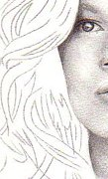
As you might imagine, the first thing you have to do is block in the hair. I've gone for a semi-curly windswept look for this one, to better illustrate how hair can by dynamic and wild. But chose whatever you're in the mood for, and go for it. When blocking in the hair- Go crazy! Hair is erratic, fluid, and never does what it's supposed to, so make your hair interesting. Just remember, as your establishing your layout, that you're not drawing hair strand by strand. That is the primary pitfall of artists when it comes to hair. Hair, like the rest of a drawing, is chunks of light and shadow, so treat them as such. Keep thinking about big blocky clumps, and the motion of hair, not individual strands.
Also, keep in mind the environment. I say environment instead of just lighting, because when drawing hair, you also have to take into consideration where the character is, what movements he/she is making, and how those factors would make the hair react. Try to see the motion in the hair when your picture it in your mind. Keep these things, as well as light source in mind while working on your layout.

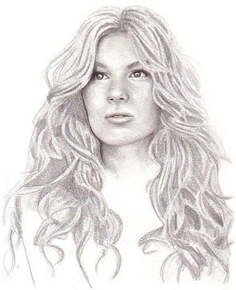
Establishing Mid-Tones: the foundation of your piece
At this stage, you're basically feeling out where the mid-tones will be. Don't be afraid to go heavy on the pencil- you can always erase it if you've added too much!
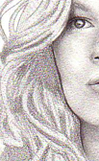
In this stage it's really important to consider your light source. Where's the light coming from? What would be light and what would be dark? Start establishing these differences in your drawing, concentrating mostly on the medium grays at this point.
At this stage, don't worry too much about what your pencil work looks like. This drawing will be going through quite a bit of layering, so it doesn't matter if it looks unrefined or sketchy. In fact, if it is sketchy, you're on the right track! Sketches have a natural spontaneity to them that do wonders for hair and motion.
Also, I'll have a quick word on hair color. Even bleach blond hair will have near-black shades, the same way black hair will have white highlights. When your dealing with a grayscale picture, I find it's more important to properly define and render the hair, the be true to the 'color' you want. That being said, if you want a 'blond' look, simply draw most of the hair in lighter tones of gray, and make them darker for brunette. If you’re confused, just open up a random picture in PhotoShop or Paint Shop Pro and make the image grayscale. Sometimes you can tell what the hair color originally was, but others you can't. Decide if the color will be a priority for you, and then do what you feel is needed to achieve the look. Intuition is a big part of the art process, and shouldn't be ignored.

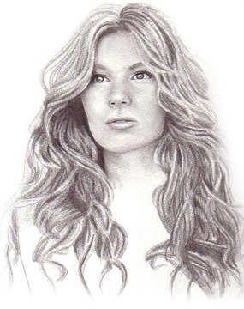
Finding Shadows: darkening it up
At this point we're hunting for shadows. Find the areas of the picture that would be darker then the already-done mid-tones, and darken them in even more. Now that you've done the mid-tones, you know what your medium gray will look like for this particular piece, so use that to decide how dark you want your blacks to be.
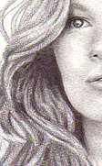
Me? I like them dark. So dark in fact, sometimes I whip out a black pen to make sure they're as black as they can possibly be. Why? Because, contrast is important. It's what makes a picture eye-catching, adds depth, and defines it. The only downside to keep in mind is that black, on it's own, tends to look flat, so keep the areas to a minimum. If you're unsure of where to use your darks, find pictures of hairstyles, and squint at them. I know it sounds kooky, but bear with me for a moment. When you squint at the picture you loose definition, but you gain shapes. And by doing this you'll be able to really pick out lights and darks, and the shapes the hair can make, without worrying about the details which people like me get bogged down in.
Remember, you're still not drawing individual strands; you're drawing shapes and tones of lights and darks. And, as always, when you're putting down your darks, keep in mind your light source. A picture with very dramatic light sources will have more contrast and heavier shadows, unlike this piece here, which has glamour lighting (glamour lighting is a photography term which basically means 'soft light'. Generally it's a main light, with a pretty strong fill light so there aren't many striking blacks, but most importantly, it makes the models 'look good'.)

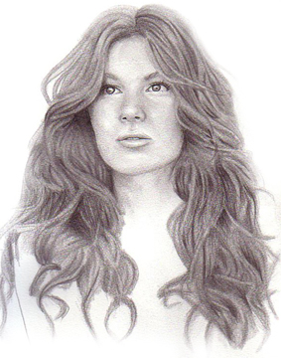
Blending it All Together: softening the piece
At this point, now that we know where we're going with the piece, and where our lights and darks are, it's time to start refining. So, take out your stump and start smudging! (And I do really recommend using a stump and not your fingers since it's easier to control, with less oil damage. But feel free to try other techniques that you're comfortable with like using Kleenex, q-tips, etc.)
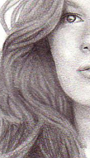
Don't really worry about losing some detail, that's part and parcel of this step. We need to smooth out all the sketchier pencil applications to create a more polished look. But use your common sense, if you feel your losing too much of the drawing, use a lighter touch, or try another blending tool. Keep in mind, that as you blend it all together with the stump, the picture will get darker. Don't worry, it's a good thing! The more layers you have on the paper, the better step 6 will be.
Be careful and test the waters when you start blending, depending on how soft a lead you've used, and what tool you use to smudge, it will be easier or harder.

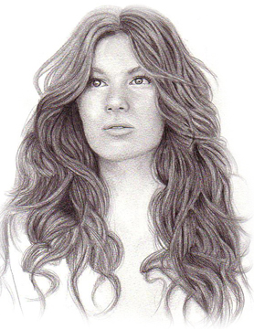
Refining Details: rendering the hair
If you're using regular pencils, it's time to switch to mechanical or to really sharpen them up. Since this step is to start adding the detail to hair, you'll need a pointy lead. So keep that sharpener on hand, since dull leads maybe nice for shading, but not for clear and crisp lines.
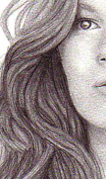
Okay, now you can start drawing lines! But don't flatten out all those beautiful tones you've created! Vary the pressure, make darker lines in dark sections, and lighter ones for the lighter. All you're really doing in this step it to make the image crisper and give it a more 'hair-like' texture by adding some detailed line-work. You're using the lines to enhance the hair, not to overpower it. Still keep the chunks of hair and motion in mind, but make them sharper and clearer on paper.

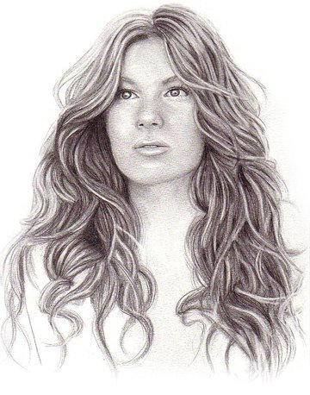
Finishing Touches: adding highlights
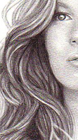
You’re almost done, I swear! This step is my favorite, adding the highlights. As you’re doing this it's really important to keep your light source in mind, as always. So, take out you Tuff Stuff eraser. If you don't have one, find another eraser (not a vinyl one, they're generally too soft for precision erasing) and use the smallest part or corner of the eraser to erase fine lines or hightlights…
Now, go crazy and pick out the highlights! Remember, you can always vary your pressure to get softer or more striking highlights, so use a nice range. And if you make a mistake, you can always add more pencil.
Just remember, with dramatic lighting (not like this picture) less is sometimes more. A few well-placed highlights on mostly dark hair can have a very striking effect.
And for a final, final finishing touch you might want to add some fixative to it. Time can do some devastating things to a work of art, especially if it's in a well-traveled sketchbook. I like to use Krylon's Workable fixative. It adds a nice protective coat without changing the image at all. Just be sure to spray in a well-ventilated area, or you'll be woozy in no time! Also, going with a fixative that says 'workable' gives you the added bonus that if you want to change something later down the line you can- without ruining the drawing.

Tips and Tricks
- As always, view hair as fluid and erratic shapes, not lines
- If you can't erase highlights, use white gouche, or a white gel pen
- Don't be afraid to find photo-references, even the pros need them from time to time.
- Practice, Practice, Practice
- Don't be afraid to not outline your images, not everything has to be liner
- Use a lot of medium grays, don't think of your piece as black and white, but as a grayscale image

'Oops, I messed up!'
First of all, don't worry about it. I mess up my images more often then I'd like to admit. Try to think of it as a learning experience rather then a failure. Try to figure out where you when wrong so you won't make that mistake twice.
Don't be ashamed of some of your first attempts, everyone has to start from somewhere. You don't get better overnight. And don't forget to keep working! You'll never get better if you don't practice.

