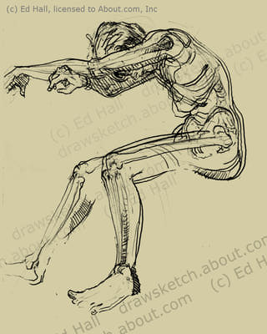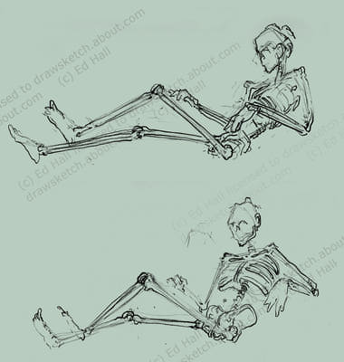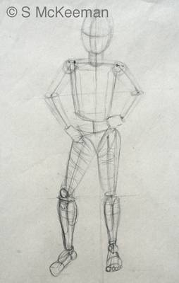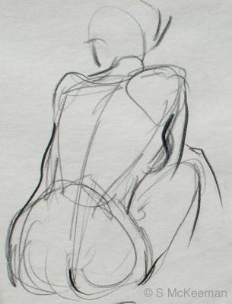
The "heads" should align on most figure drawings this way:
- First head length: head!
- Second head length: chest line at nipples.
- Third head length: waistline, at bellybutton.
- Forth head length: groin area.
- Fifth head length: a bit above the knee.
- Sixth head length: just below knee.
- Seventh head length: above ankle (or mid-calf, if the person is 8 heads).
- Seven & 3/4 (or eighth) head length: at bottom of feet.
Other measurements that should be noted:
- When the arms are at the side, the wrist bone aligns with the groin area.
- The elbow aligns with the waistline—around or above the bellybutton.
- Shoulder width, side-to-side is about 2 to 2 1/3 heads wide.
