Art With Text

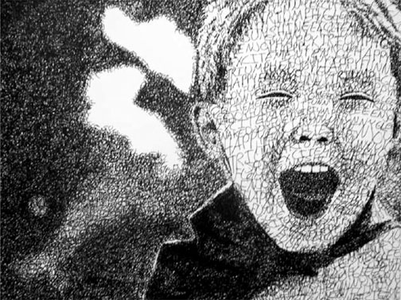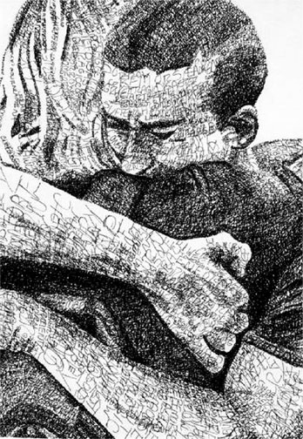
Description
You will complete a pen and ink drawing using words to determine values. By choosing a picture to work from with high emotional content and then using a thesaurus to select words that describe the picture's content, you will help ensure the success of this project. Words should be placed together tighter, made bolder etc. to achieve darker values.
Materials: pencil, pen and ink paper, permanent ink pens, thesaurus
STEPS
1) Select a picture of yourself that creates a feeling of emotion in you when you view it. The stronger you feel about the subject matter or theme, the better. If the picture is not black and white, a black and white copy should be made. In this stage, you will work on your thumbnail sketch. You may crop, enlarge, reduce, add details, leave out some details, create a composite thumbnail of several images, etc.
2) Complete a light line drawing of the picture. Be as accurate as possible. The finished product is never better than the original drawing.
3) This step is inter-changeable with step 2; using a thesaurus, compile a list of at least ten words that describe the feelings or emotions of the image.
4) Beginning with the darkest areas first, start laying in your words, obviously change the words as you go along, rather than repeating the same word over and over. Make the words tighter, more condensed, etc in the areas that need to be darkest. Spread them out as you get lighter. This is very much like stippling or pointillism, only you are using words instead of dots.
5) Complete the entire picture using words to define the picture and its different values.
6) Complete the self-evaluation portion of your sheet. Use all the terminology introduced with this lesson.
Requirements:
1) You must choose a picture that brings about an emotional response when viewed.
2) You must work from an approved thumbnail sketch.
3) All lines, shading, etc. are done with words only.
4) A full range of values must be present in the completed drawing.
5) The finished drawing will be completed in pen and ink.
6) The self-evaluation and artist statement must be completed.

