Burnishing with Colored Pencil | A Demonstration by Gary Greene
Burnishing involves layering and blending until no paper tooth shows through the colored pencil layers. To avoid contamination of lighter colors, layer lighter colors on top of darker colors. After all colors are layered, the artist mixes—or burnishes—all but the darkest color in a given color area, using white or any light color, depending on the desired effect. The same sequence of colors is then re-layered over the entire color area. This process is repeated until the colored pencil areas completely cover the paper beneath them, allowing no tooth to show. All colors in this demonstration are Prismacolor.
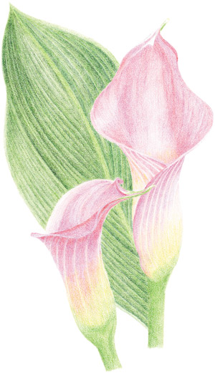
Layer color areas in the following order. Starting with the petals, layer cool gray 30%, 20% and 10%; magenta; process red; hot pink; pink; deco pink and cream. Then layer the stems with grass green, olive green, apple green, spring green and cream. Finally, layer the leaf with grass green, olive green and cool gray 30% and 20%.
.
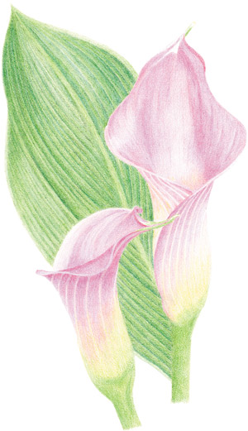
Burnish each color area with white, avoiding the darkest (shadow) hues.
.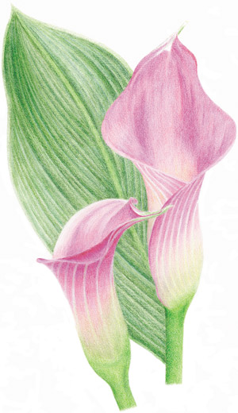
Re-layer the colors as you did in the first step.
.
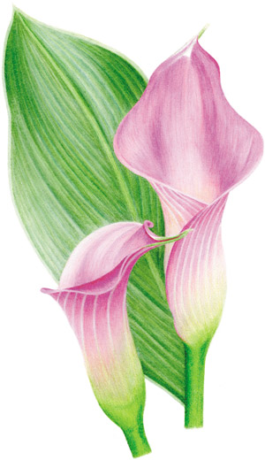
Repeat burnishing and layering until no paper shows through the colored pencil. Finish the work by burnishing each entire color area with a colorless blender pencil.
Gary Greene has been a full-time artist since 1967 and is the author of four books and videos on colored pencil techniques, including No Experience Required: Colored and Watercolor Pencil. This demonstration is an excerpt from his article “Uptight is All Right” in the November 2008 issue of The Artist’s Magazine.

A study in the use of Grisaille
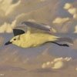
I'm Rob Simson and this lens features one of my colored pencil paintings titled "Storm Rider".

Storm Rider Step-by-Step
I start with a contour line drawing of the subject. Once I'm happy with the layout, I begin laying in the value. You can see where I've started in the upper right corner. This technique is called "Grisaille". You complete the value in gray scale, then layer color over the top.
For the background I'm using Prisma Color Warm Grey 50%. I'll use darker grays for the bird. This will help to bring the bird forward and give the work depth.
I have embellished the contour drawing in this photo to make it easier to see online. The actual contour drawing is very light.

Storm Rider Step Two
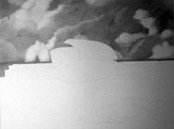I continue on the background values.
I like to work from left to right, top to bottom. Because I am right handed, working this way helps me avoid placing my working hand on top of areas I have already colored. If I do have to rest my hand on top of areas I've already worked, I place a smooth plastic notebook cover between my hand and the artwork. This protects the art from the oils and abrasive surface of my hand.
One of the characteristics of colored pencil I enjoy is the ability to allow some of the surface of whatever I am coloring on to show through as opposed to burnishing or blending the pencil to a full coverage. What happens is the pencil only leaves pigment on the high points of the texture of the surface. The low points then show through (or more accurately, between) the color being laid down. This technique gives the the artwork a little bit of a grainy appearance or seem to sparkle.

Storm Rider Step Three
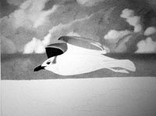I begin to lay down values for the bird.
Although I don't usually do this, I use black for the darkest values. I want the contrast between the bird and the background to be as strong as possible. I use warm grey 70% for the wings, body, and tail.
For the lightest areas of shading I use no more pressure than the weight of the pencil.

Storm Rider Step Four
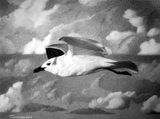Next I finish the gray scale values.
I take this opportunity to clean up some spots and adjust light or dark areas until I'm happy.
Next, we add some color!

Storm rider Step Five
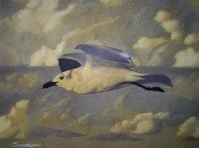I begin with the lightest color first, Spanish Orange.
I concentrate the color in the mid-tone areas where sunlight is hitting the bird and penetrating the clouds. I'll be applying Parme Violet and True Blue to the darker areas.

Storm Rider Step Six
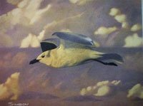Now I layer on Parme Violet.
Note on clouds: A wise man once told me never to render clouds without a reference. I agree. (After many failed attempts without one) Clouds do weird things that I wouldn't normally think would look right. I imagine that after years of painting clouds you might be able to successfully fake it, but I don't think I would try it even then.

Storm Rider Final Step
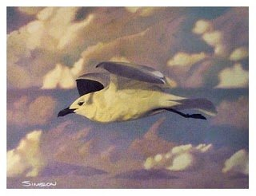
Finally, I layer on True Blue.

