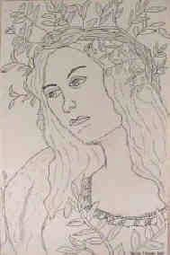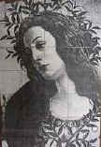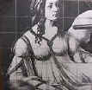
Grid Drawings

- Measure your photo/reference
- Divide it into equal parts (usually in inches or ½ inches)
- Figure out how large your paper should be based on the size of the original photo or reference
- Divide your drawing into the same number of parts in the larger increment you choose

