Pointillism - is a technique of painting in which small, distinct dots of pure color are applied in patterns to form an image.
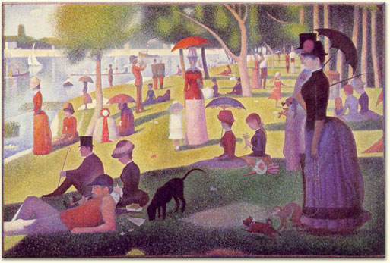
Sunday Afternoon on the Island of La Grande Jatte (Un dimanche après-midi à l’Ile de la Grande Jatte), Georges Seurat, 1884-1886.
Object: To create a drawing using pointillism and/or gestural or painterly marks on a prepared surface.
*Pay attention to color schemes
Materials: Cardboard and oil pastels
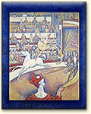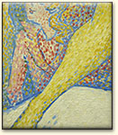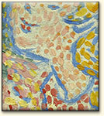
The Circus, Georges Seurat, 1890-91. Full painting, and two detailed views. This appears to be the first painting in which Seurat shows his debt to the newly-developed art of the poster, in particular the celebrated Cheret.
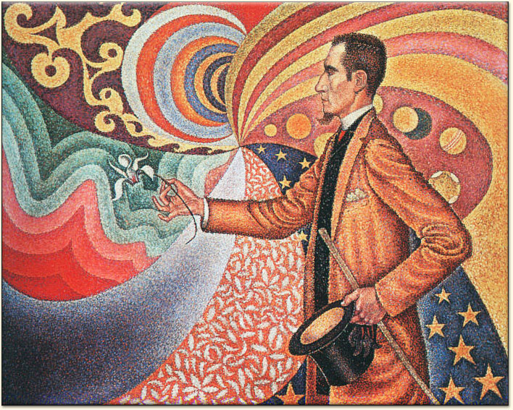
Rubric:
Composition
Use of color (including color schemes)
Craftsmanship (neatness and planning)
Accuracy (in comparison to the original)
Consistency (of marks/dots)

Georges Seurat and Paul Signac developed the technique in 1886, branching from Impressionism.

