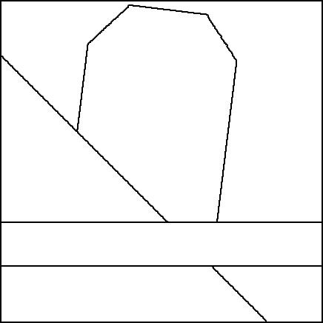 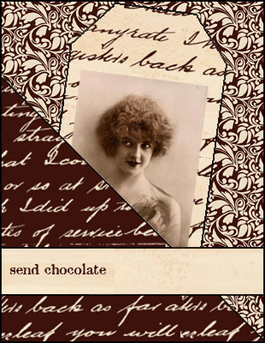

[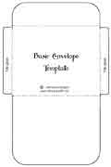](http://www.allcrafts.net/crochetsewingcrafts.htm?url=www.ruthannzaroff.com/mirkwooddesigns/basiccard.htm) 