Gouache
The name derives from the Italian guazzo, and is also referred to as opaque watercolor or bodycolor (the term preferred by art historians).
Gouache paint is similar to watercolor but modified to make it an opaque painting medium.
Gouache differs from watercolor in that the particles are larger, the ratio of pigment to water is much higher, and an additional, inert, white pigment such as chalk is also present. This makes gouache heavier and more opaque, with greater reflective qualities.^{[1] (wikipedia)}

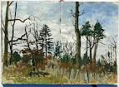
Palette: Any covered watercolor type palette or butcher's tray (cover butcher's tray with plastic wrap when not in use).

SUPPLIES

Brushes: Sable and artificial sable brushes work best. (Your choice of size and shape)

Surface: Illustration board cold or hot-press and watercolor paper 140lb or 300lb cold or hot- press. (Your choice of brand)

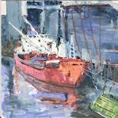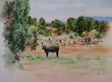

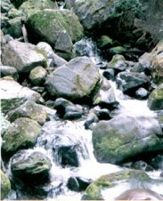 | 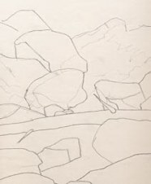 | 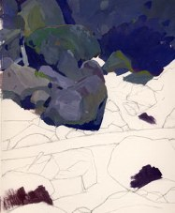
The Photograph©  Courtesy of Maury Kettell,  "Projects Page" | Drawing ©  I drew my composition directly onto 140lb Lanaquarelle 9" x 12” watercolor paper. I stayed pretty true to the photograph but added the fallen log for additional interest. | Beginning ©  I chose a Blue-Purple as my dominant hue with Cadmium Yellow-Orange as the complimentary color. Cobalt Blue and Violet are the adjacent hues to the Blue-Purple with Yellow-green and Yellow-Orange as the two discord colors. I went back and refined my drawing by adding a few more rocks for interest.
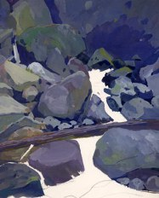 | 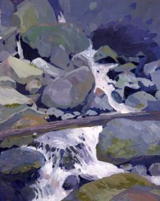 | 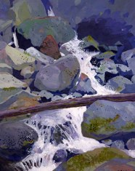
Midway ©  This is where the fun part begins. I usually pick one main element in my painting, and connect everything else to it. At this point I have a pretty good idea where I'm going with the painting. Now it's just a matter of working the painting as a whole. | Nearing Completion©  Working the painting as a whole, checking to see where improvements can be made. Painting and refining the water was very enjoyable and relaxing. I had to keep in mind that the rocks both above and below the water line will influence the color of the water. | Finish©  I added some additional dark areas back in the foreground rocks. I got carried away with flinging paint, both dark and light. I did enjoy the process.
(http://krobbins4art.tripod.com/id7.htm)

