Dolls or puppet
For this assignment you’ll create a doll inspired by an artist. The doll can use the likeness of the artist (but doesn’t have to) & has to be at least inspired by the artist (exp. Could be VanGogh inspired but not actually resemble VG; maybe has a sunflower in his T-shirt, etc.).
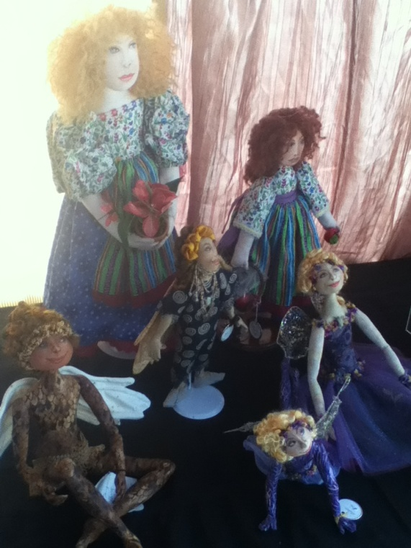
The doll could also be in a genre; but think ‘fine arts craft’ (as much as I LOVE The Simpsons – and I do! I wouldn’t make a Bart doll for this assignment – not original enough!)
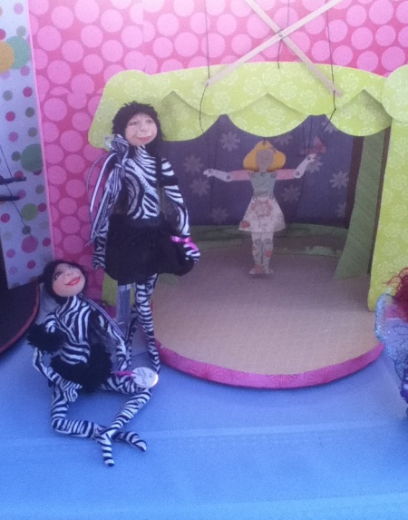 Prior to starting, you must have 3 drawings of the doll of your choice in your sketchbook; a front view, a back view & an accessories page. They must all be in color!
Doll/puppet heads will be made of model magic OR fabric (your choice).
Body will be plush
You must hand stitch some part of your costume (hot glue may also be used)
At least one accessory must be included (can be made from model magic, sculpey, sculpted from foam, etc.)