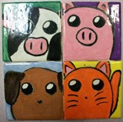Underglaze Tile Design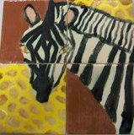
1. Draw 3 possible tile configurations in your sketchbook (Large enough to plan details & color)
2. Pick your favorite and color it (can be B & W)
3. Choose 4 bisque tiles (3x3 or 4x4)
-Finished mural will be 9x9 or 12x12
4. Color/paint with Underglaze; being careful not to smudge dark colors (don’t drag). Work from left to right if right handed (opposite for left). 2-3 coats of Underglaze are needed for solid color. If you want a more transparent effect, water down the glazes & do 2 transparent layers. The end effect will be translucent.
5. Finish with Overglaze, being careful not to ‘pull’ color. Dab Overglaze on as opposed to ‘pulling’ it with the brush to keep colors pure & clean.
