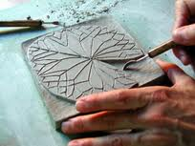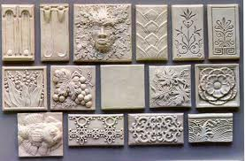
RELIEF
TILES
TERMS: Raised, relief, incised, radial
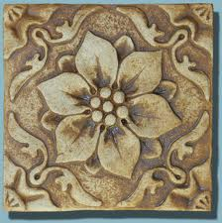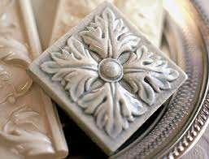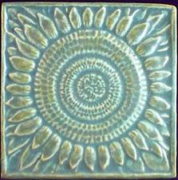

- Design must include raised areas & incised areas
- Radial design (1 image)
- Tiles will be 8x8
- About ½ inch thick
- Will start square but the shape may be changed
*Note: Keep corners down!!!

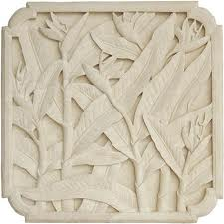

Relief Tile
Relief is a sculptural technique. The term relief is from the Latin verb levo, to raise. To create a sculpture in relief is thus to give the impression that the sculpted material has been raised above the background plane. –Wikipedia
Coins are an example of bas-relief (low relief)
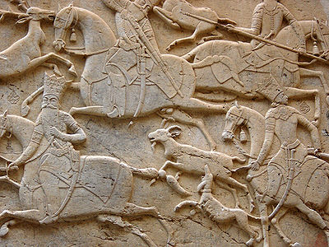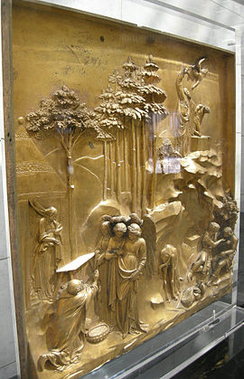

Rules & Tips:
-*Don’t dry it too fast – when done place in an open bag, remove from bag the next day
-*DON’T wrap clay in canvas & put it in a bag. This will cause the canvas to MOLD!
-Don’t go any thicker than twice as thick as the tile thickness
-You must use additive and subtractive techniques
-(You can ‘subtract’ clay from an area you added; this would count)
-Tap the corners of your tiles down to make sure it stays flat (or they’ll curl)
-Make sure not to trap air behind clay added to avoid explosions!

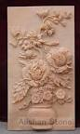

*These are rules for clay for this project & for always!

