1. Select Groups from Admin Menu | 2. Set Up Group and Click to Save
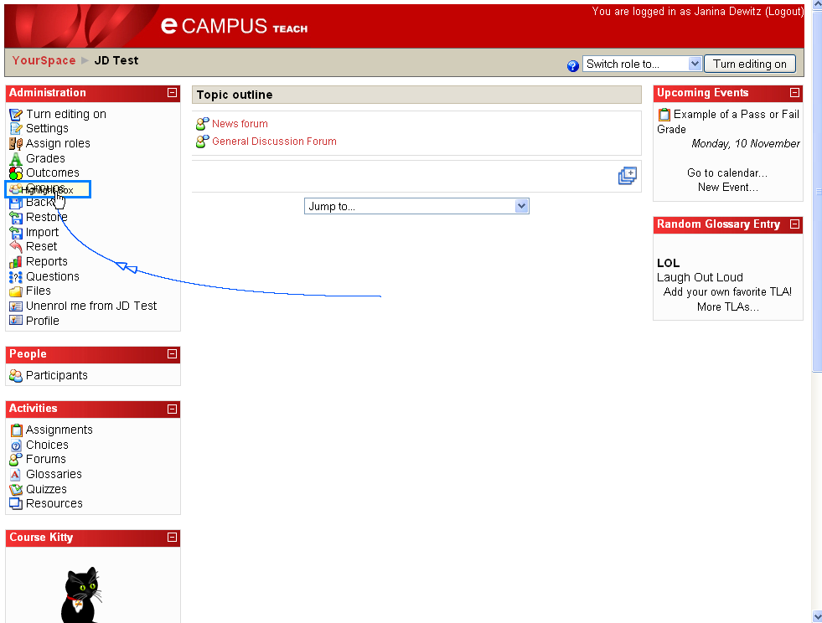 | 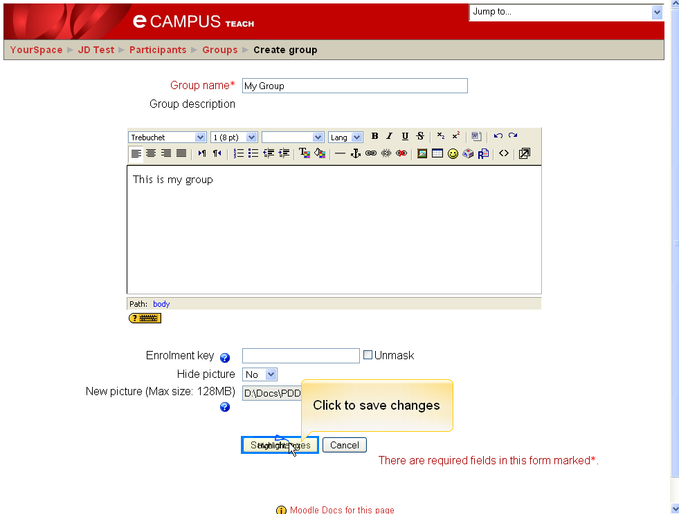
3. Highlight Group name and Add Participants | 4. Select Participants and Add
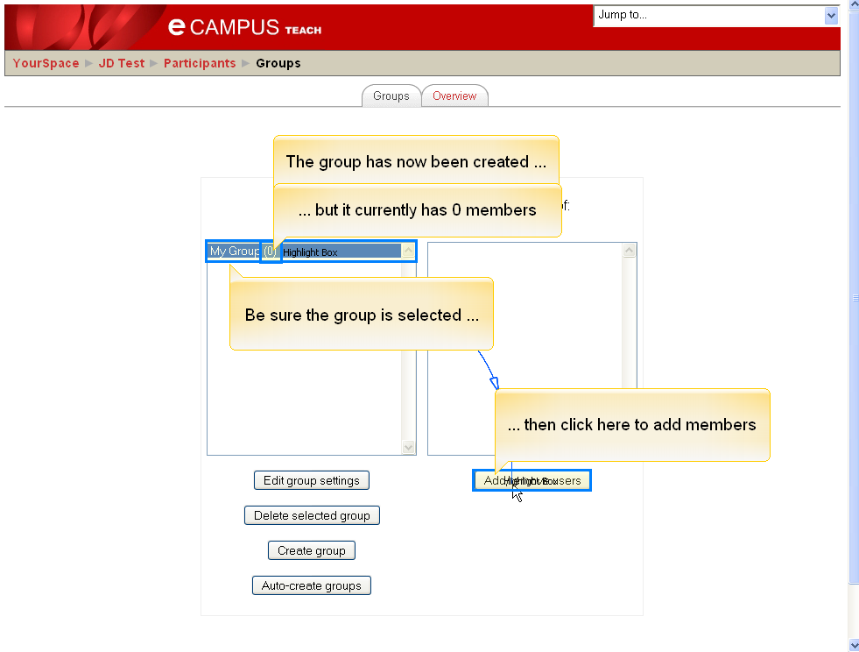 | 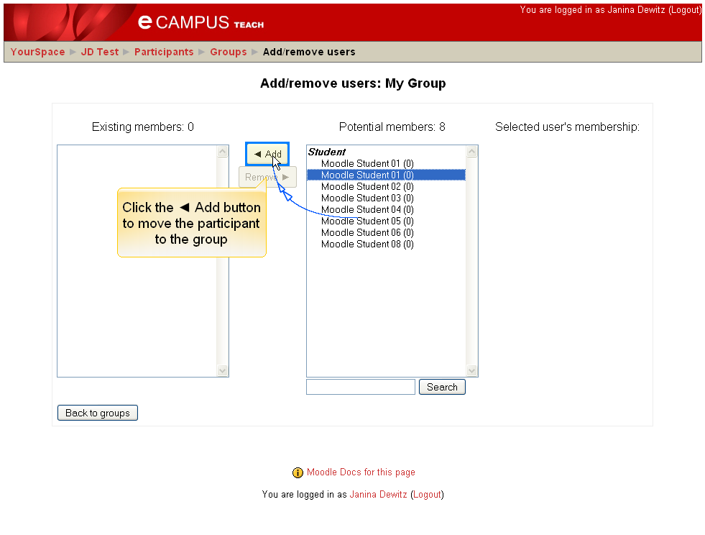
5. Ctrl+Click to add multiple Participants at once | 6. Select and Remove
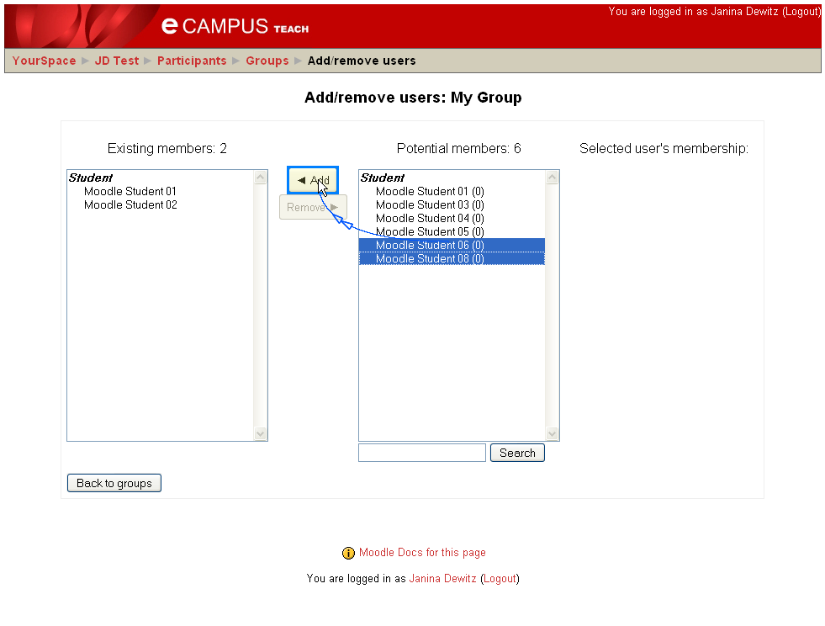 | 