1. Select Grades from the Admin Block | 2. Go to Edit Scales
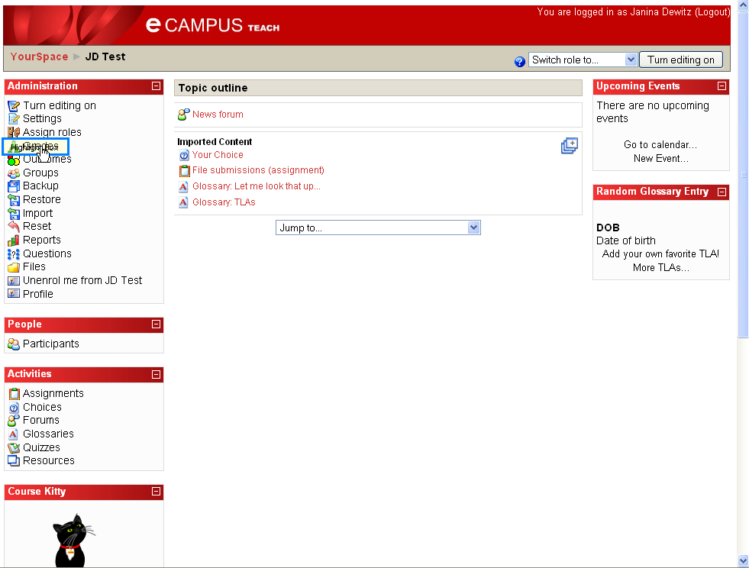 | 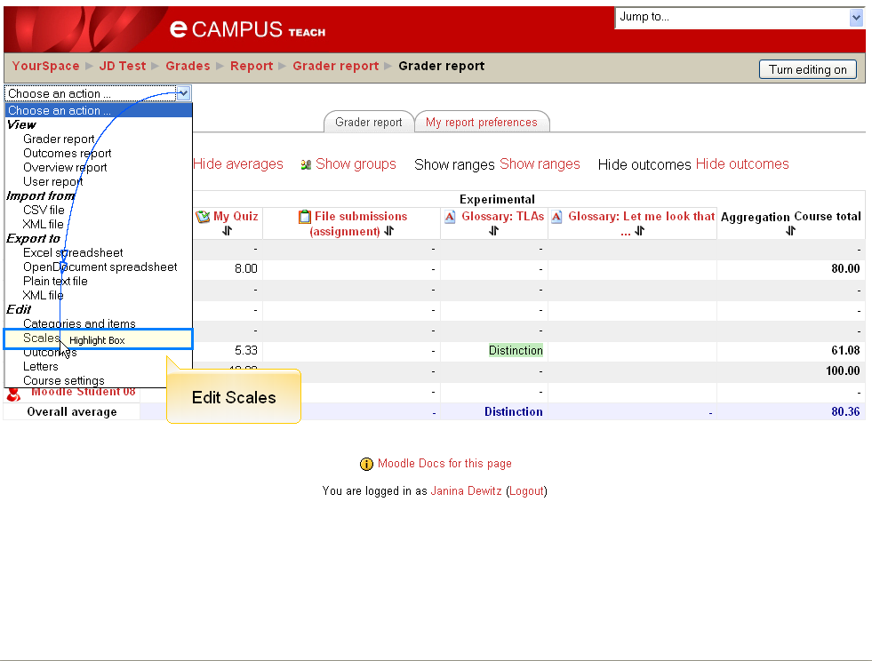
3. Click Add New Scale | 4. Enter Name and Scale Items
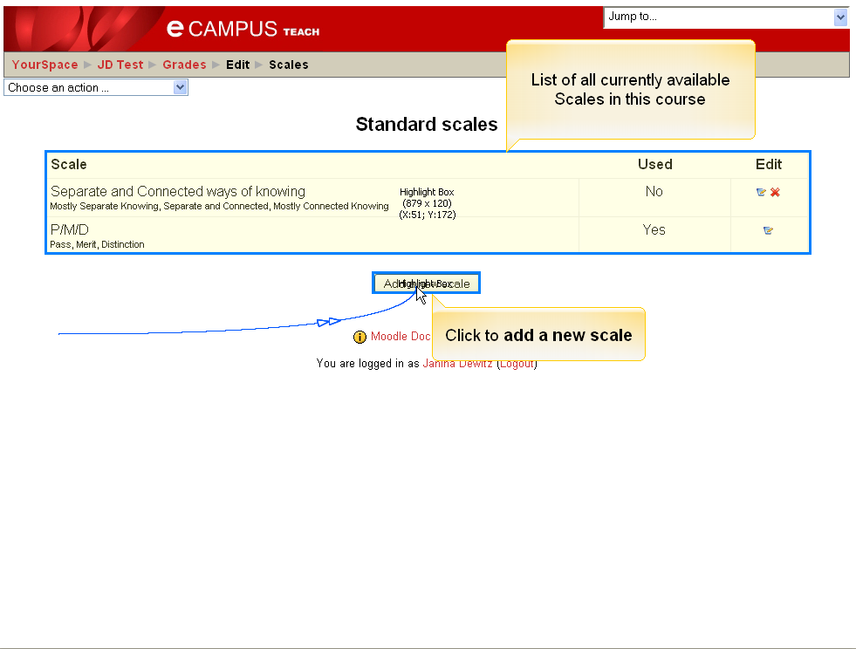 | 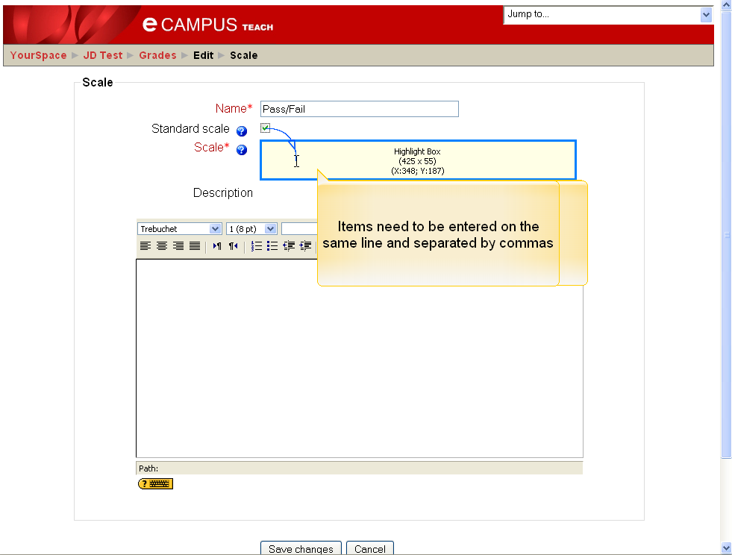
5. Add a Description and Click Save | 6. Return to Course Page
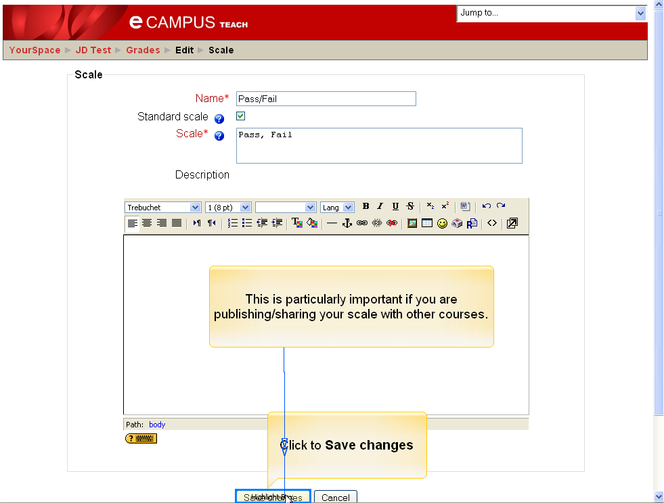 | 